Task on VPC Transit Gateway & VPC Endpoint
- Create one VPC, with 1 public subnet and 1 private subnet.
- Login to aws console.
- Navigate to VPC Your VPCs create VPC.
- Select VPC only.
- Update with the required details:
    - Name tag: my-custom-vpc
    - IPv4 CIDR block: 10.0.0.0/16
    - Tenancy: default
- Click on Create VPC.
- Go to subnets Create Subnet
- Select VPC as my-custom-vpc
- Update with the required details:
    - Subnet name: public-subnet-1
    - Availability Zone: any region
    - IPv4 CIDR: 10.0.1.0/24
- Click on create subnet.
- Select the subnet click on actions edit subnet settings
- Enable ‘auto-assihn public IPv4 address’ and save.
- Create another subnet in same VPC.
- Update with the required details:
    - Subnet name: private-subnet-1
    - Availability Zone: any region
    - IPv4 CIDR: 10.0.2.0/24
- Click on create subnet.
- Do not enable auto-assign public IP here.
- Now navigate to internet gateway and create internet gateway.
- Name it as my-igw
- Click on actions attach to VPC and select my-custom-vpc
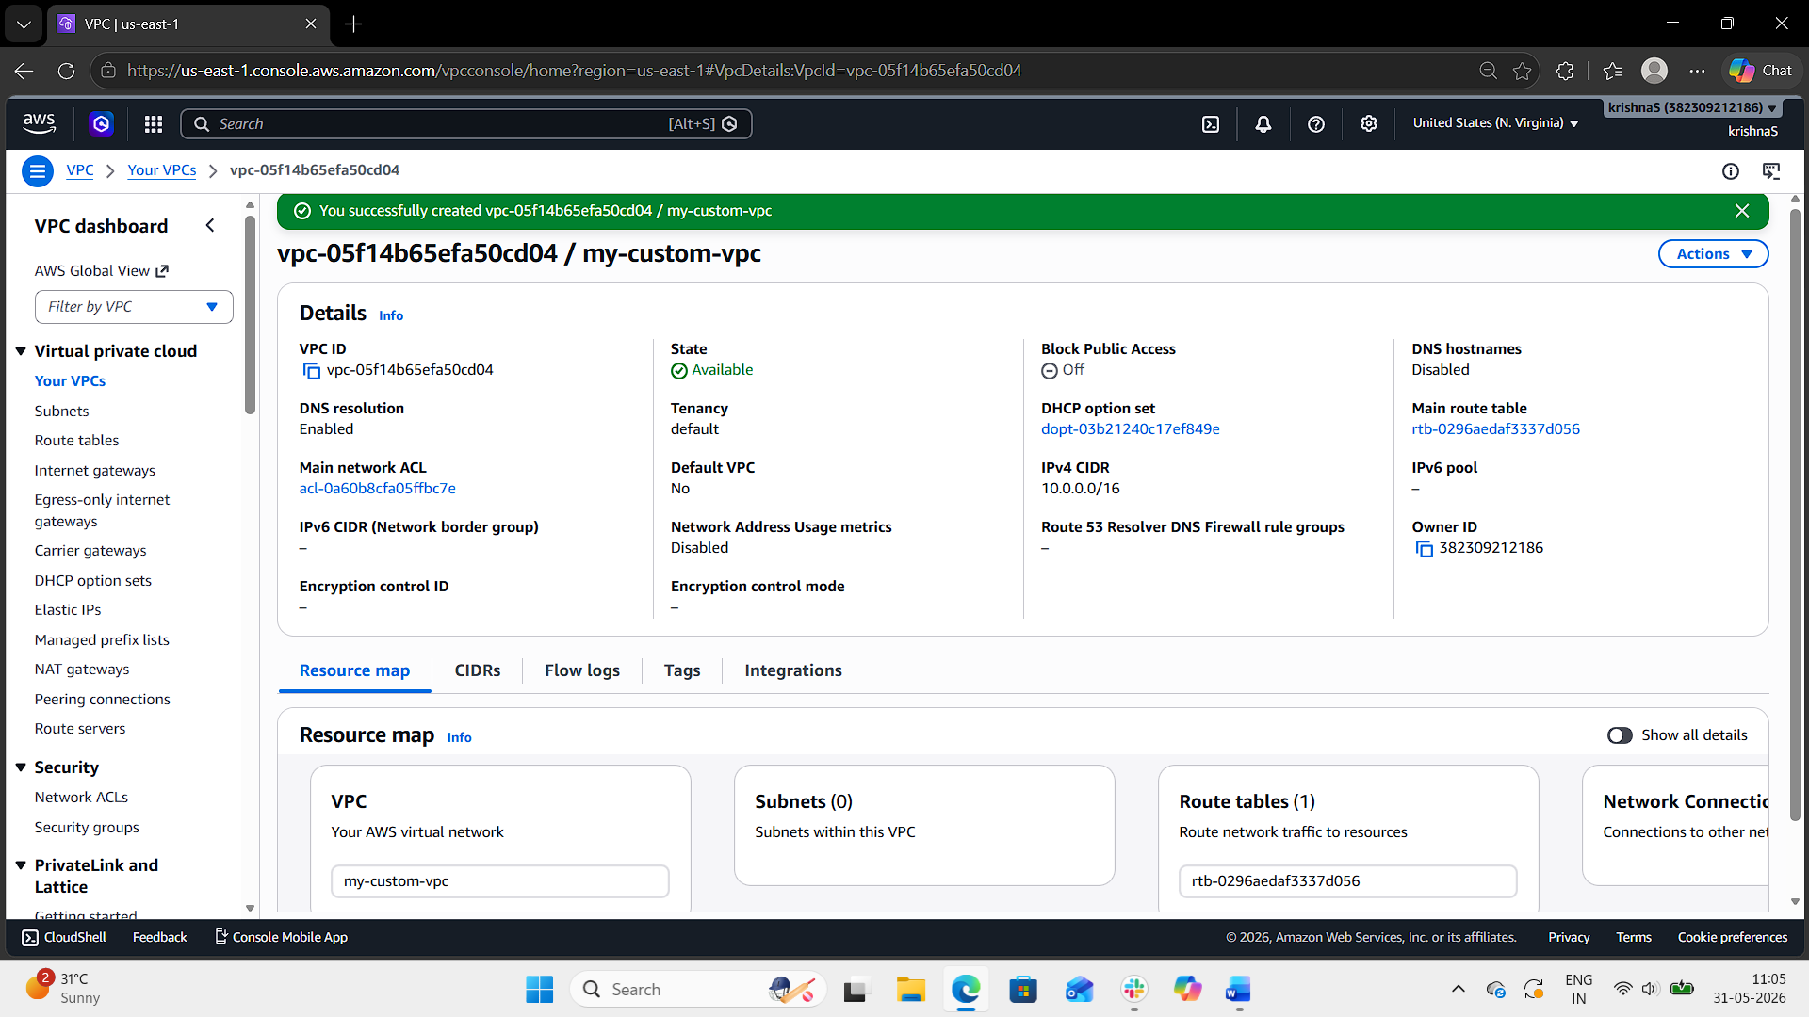
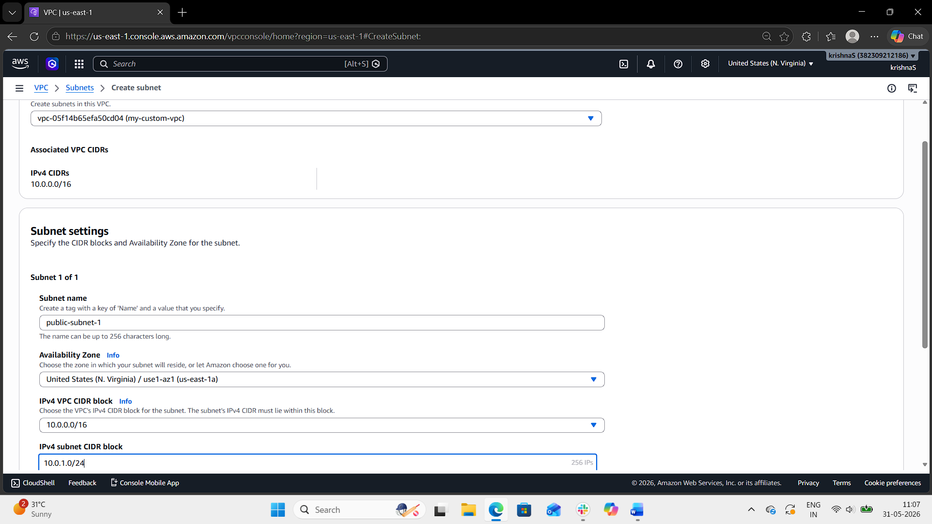
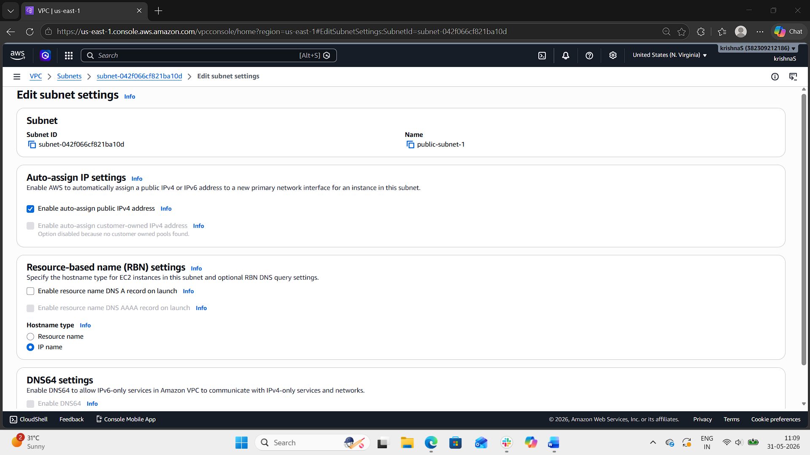
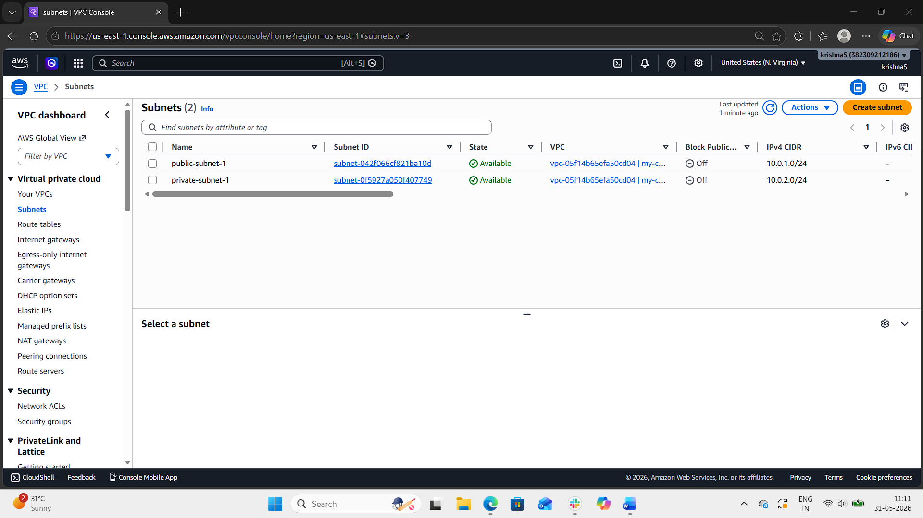
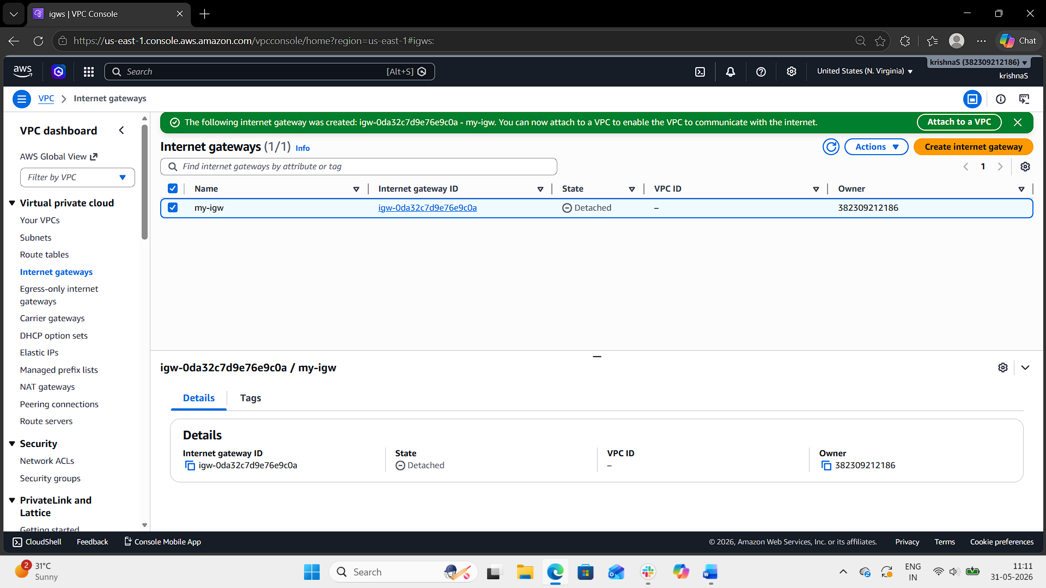
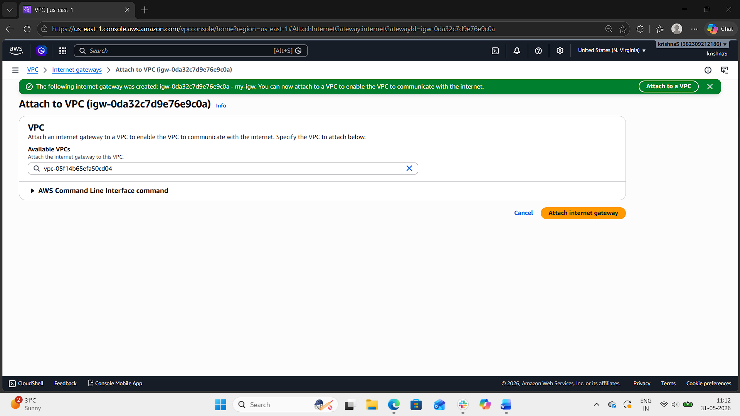
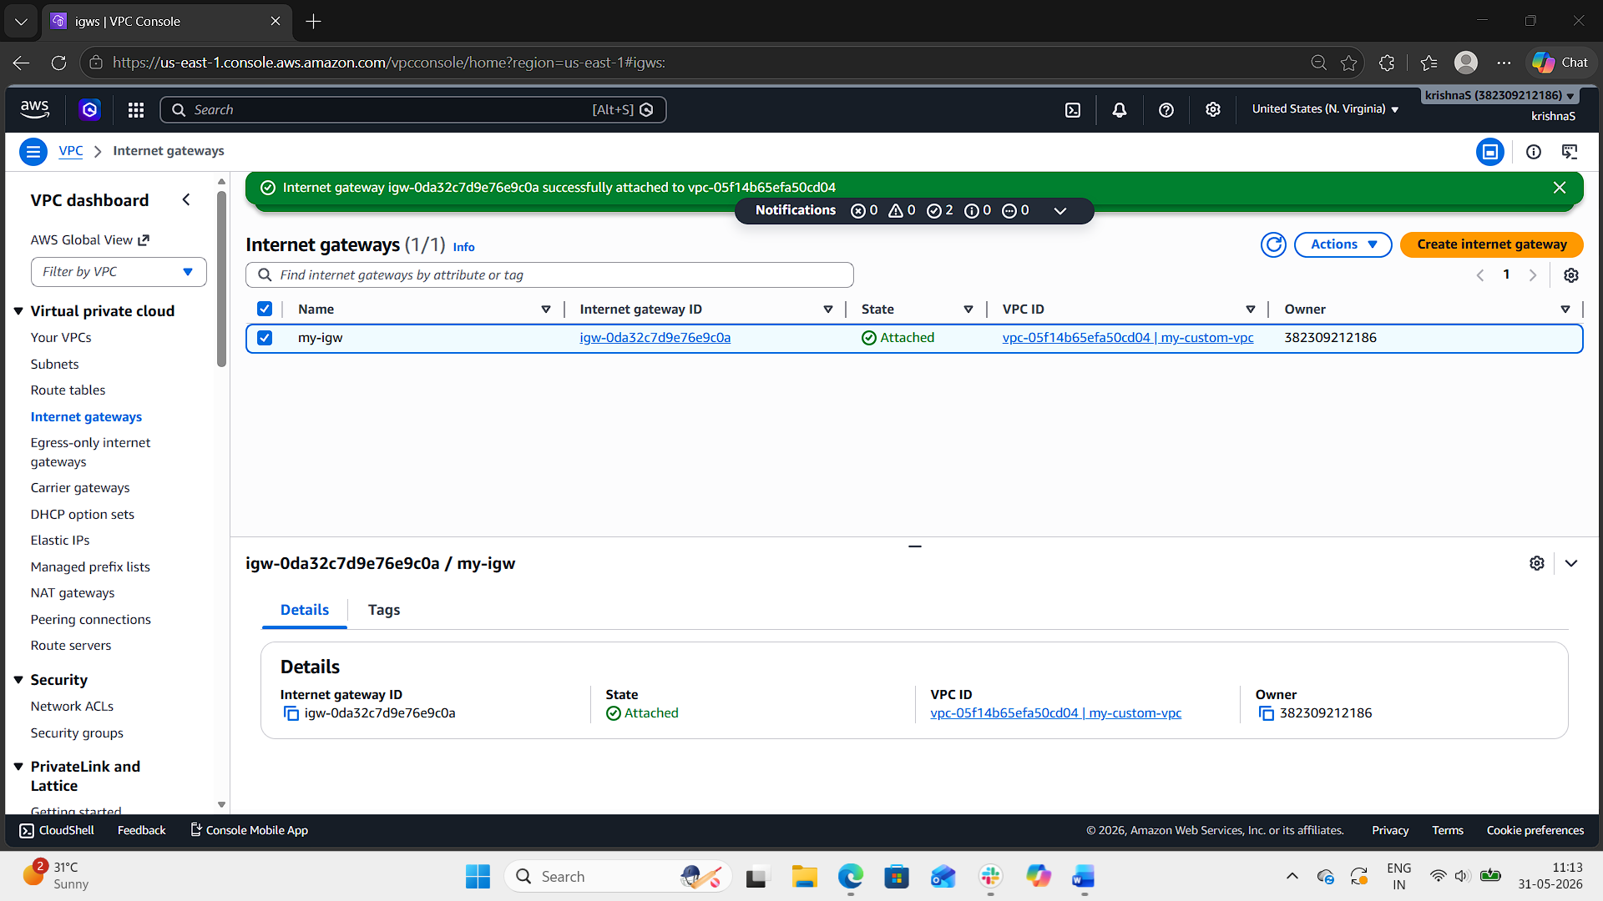

- Enable VPC peering for cross-region.
- Login to aws console.
- Open VPC.
- Change the region to N. Virginia (us-east-1).
- Go to Your VPCs and click Create VPC.
- Select VPC only.
- Enter:
  - VPC Name: virginia-vpc
  - CIDR Block: 10.0.0.0/16
- Click Create VPC.
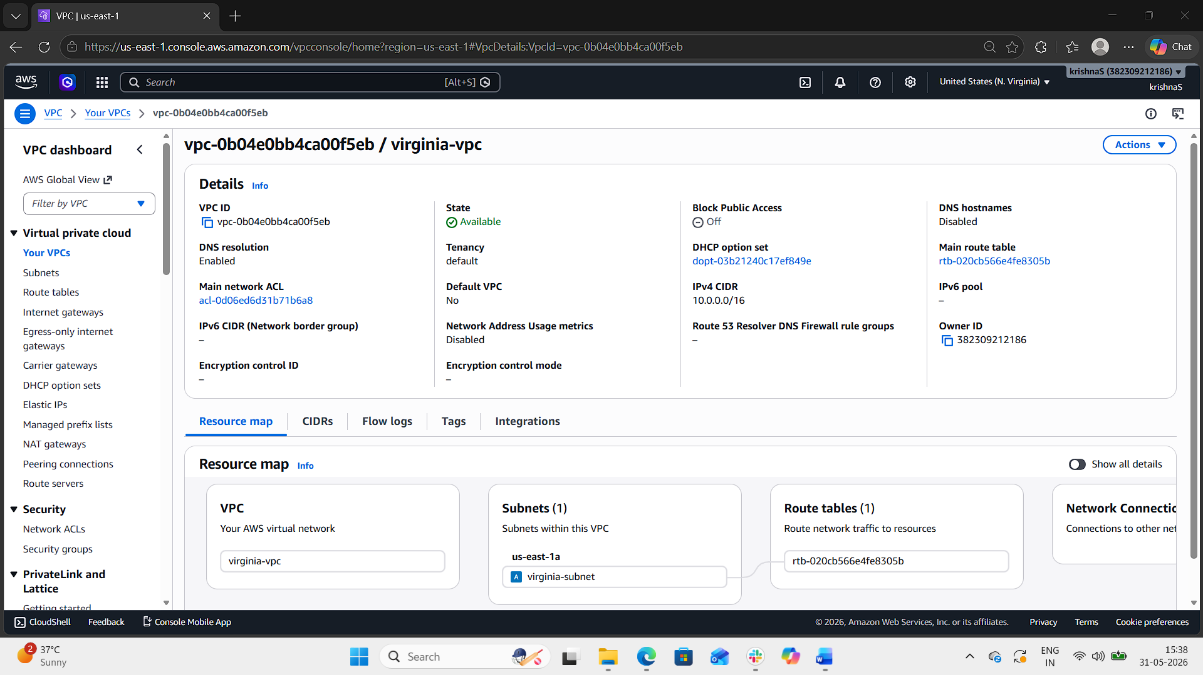
Step 2: Create Subnet in N. Virginia
- Go to Subnets.
- Click Create subnet.
- Select virginia-vpc.
- Enter:
  - Subnet Name: virginia-subnet
  - Availability Zone: us-east-1a
  - CIDR Block: 10.0.1.0/24
- Click Create subnet.
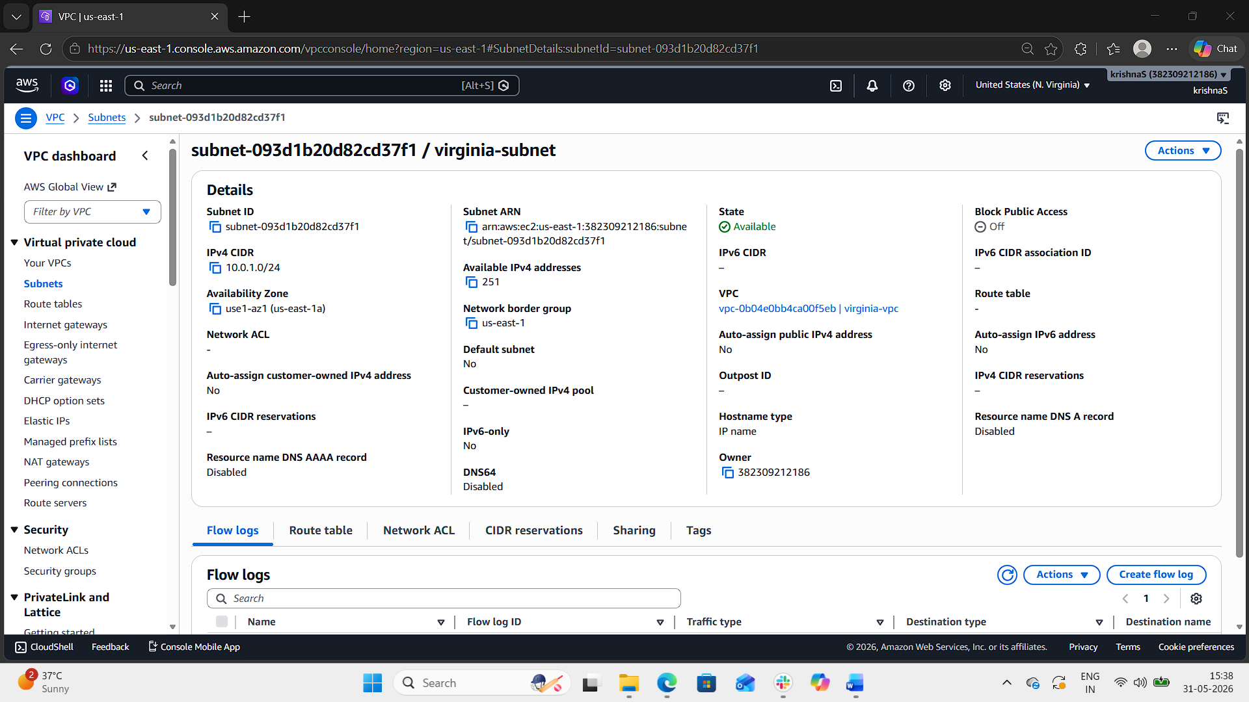
Step 3: Create Internet Gateway for Virginia VPC
- Open Internet Gateways.
- Click Create internet gateway.
- Enter name:
  - virginia-igw
- Click Create internet gateway.
- Select the IGW and choose:
  - Actions → Attach to VPC
- Attach it to virginia-vpc.
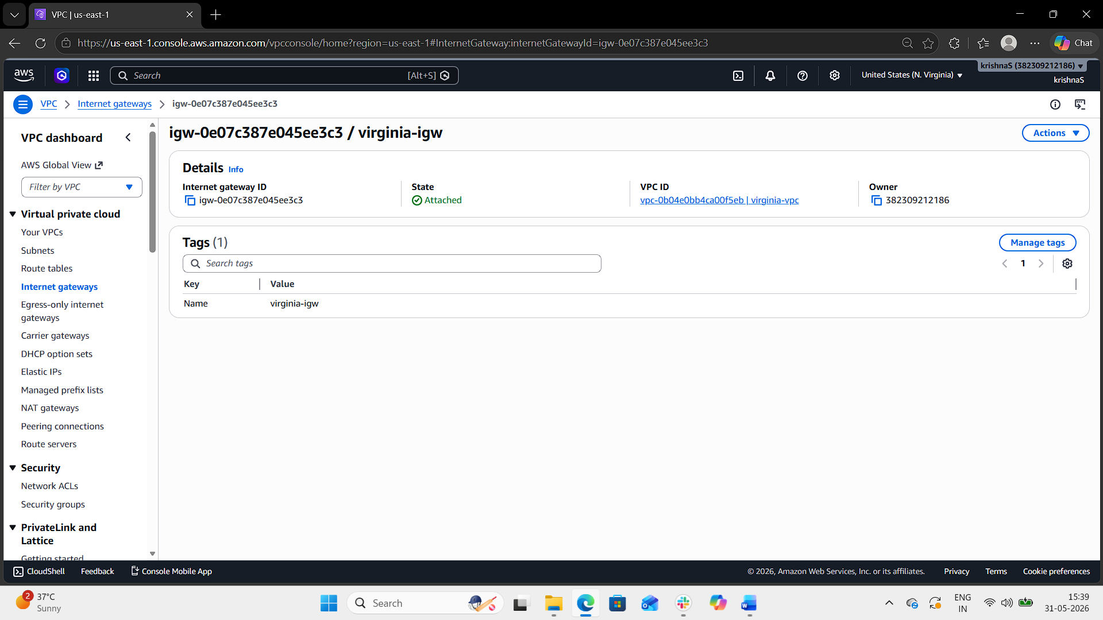
Step 4: Configure Route Table in Virginia
- Open Route Tables.
- Select the route table associated with virginia-vpc.
- Click Edit Routes.
- Add route:
Destination | Target
0.0.0.0/0 | Internet Gateway
- Save changes.
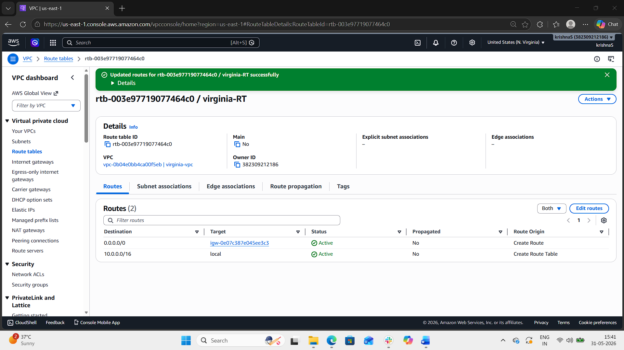
Step 5: Create VPC in Ohio
- Change region to Ohio (us-east-2).
- Go to Your VPCs.
- Click Create VPC.
- Select VPC only.
- Enter:
  - VPC Name: ohio-vpc
  - CIDR Block: 20.0.0.0/16
- Click Create VPC.
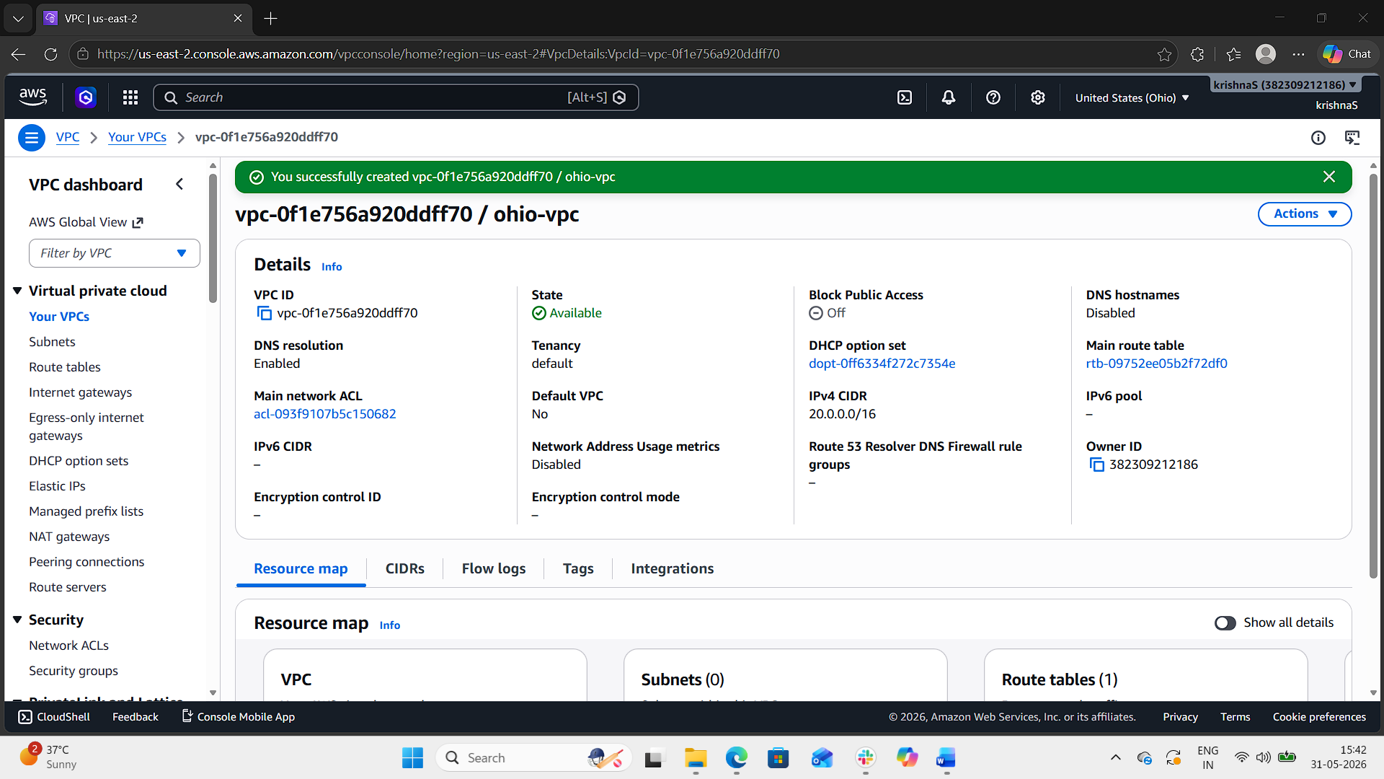
Step 6: Create Subnet in Ohio
- Open Subnets.
- Click Create subnet.
- Select ohio-vpc.
- Enter:
  - Subnet Name: ohio-subnet
  - Availability Zone: us-east-2a
  - CIDR Block: 20.0.1.0/24
- Click Create subnet.
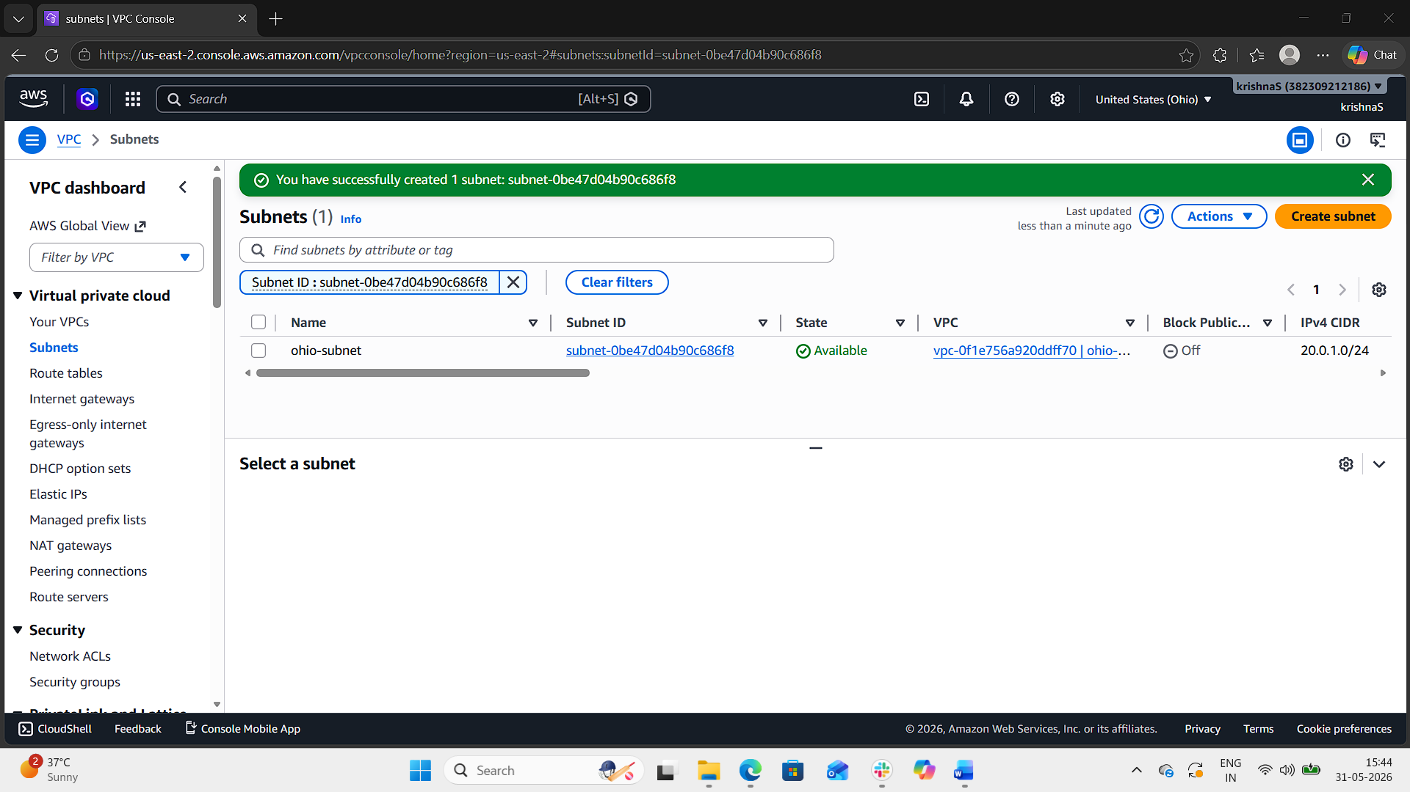
Step 7: Create Internet Gateway for Ohio VPC
- Open Internet Gateways.
- Click Create internet gateway.
- Enter:
  - ohio-igw
- Create the IGW.
- Attach it to ohio-vpc.
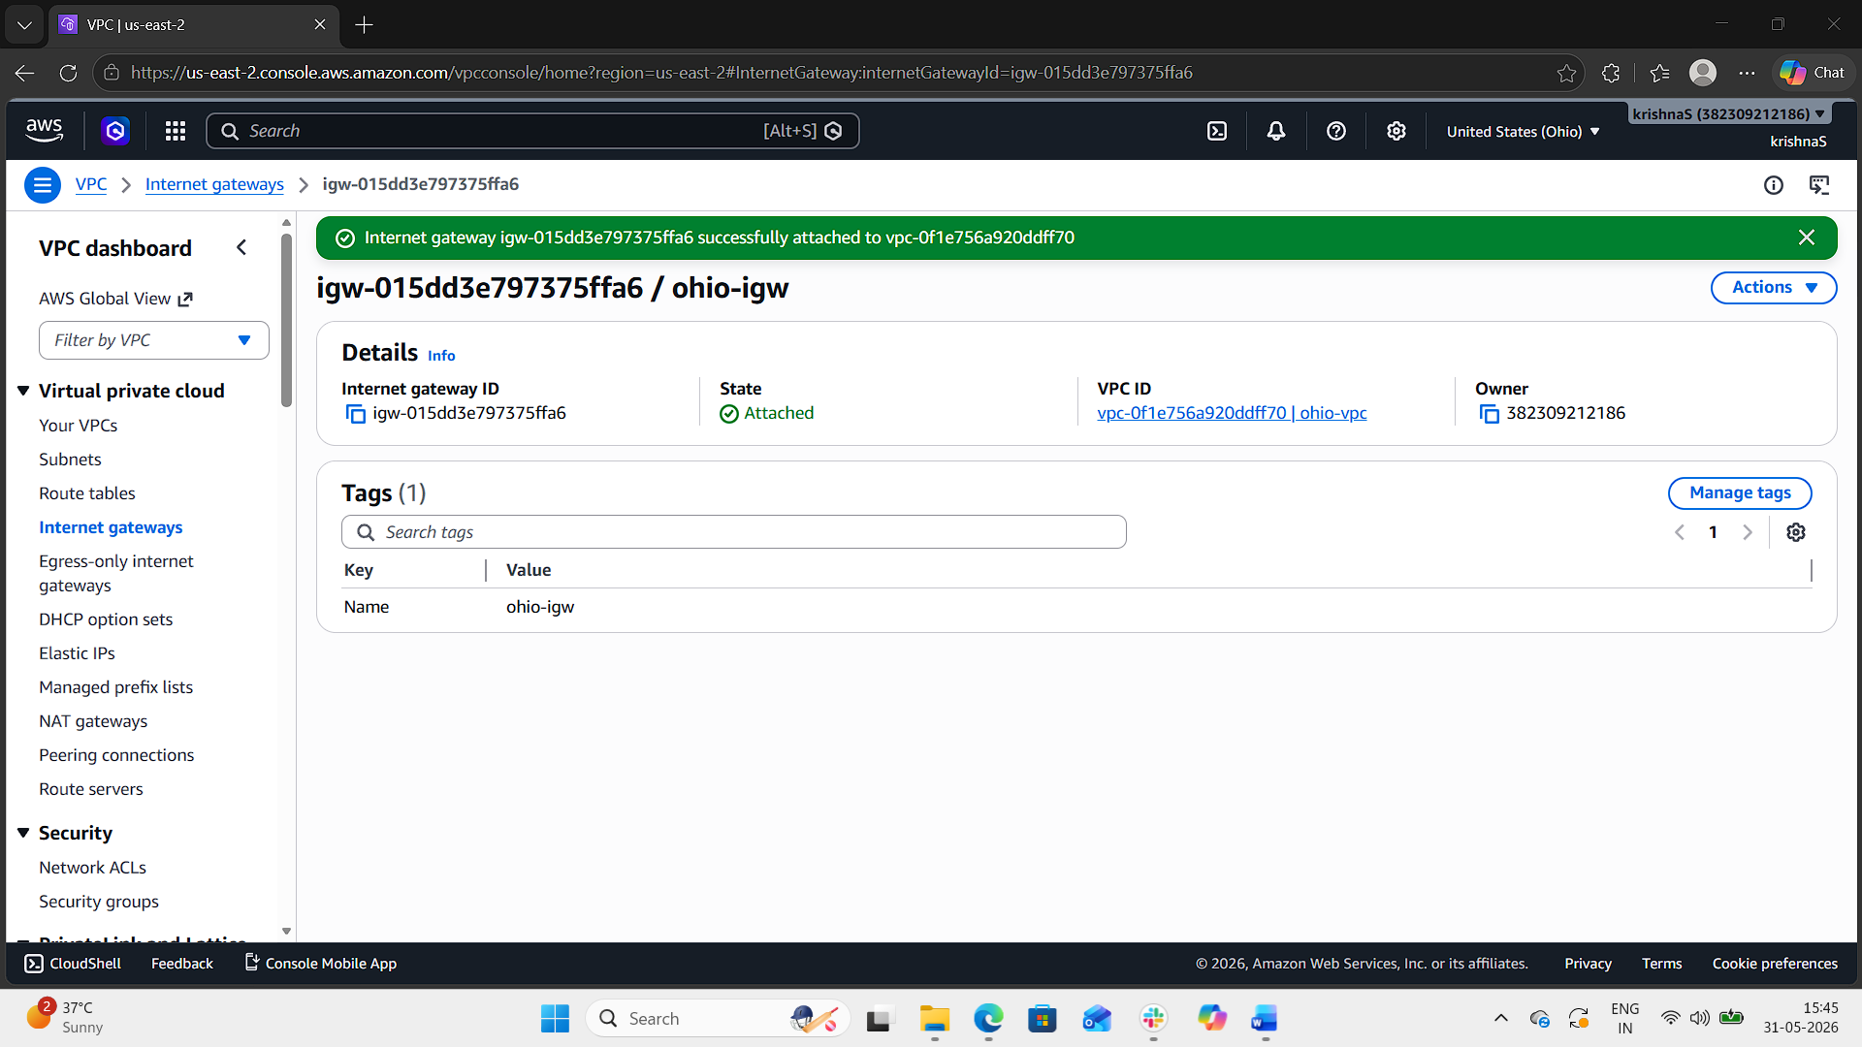
Step 8: Configure Route Table in Ohio
- Open Route Tables.
- Select Ohio VPC route table.
- Click Edit Routes.
- Add:
Destination | Target
0.0.0.0/0 | Internet Gateway
- Save changes.
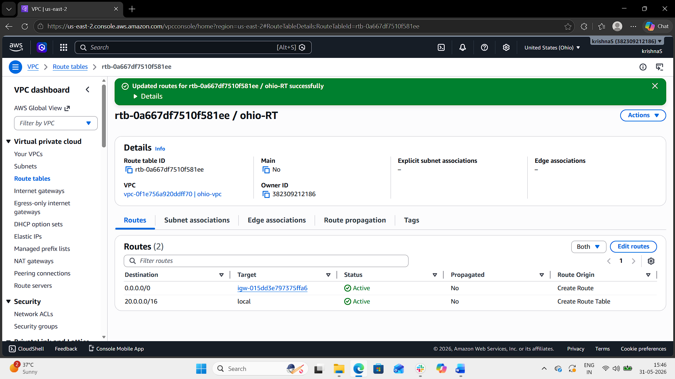
Step 9: Launch EC2 Instances
- Launch one EC2 instance in each VPC using Amazon EC2.
Virginia EC2
- VPC: virginia-vpc
- Subnet: virginia-subnet
- Auto-assign Public IP: Enabled
Ohio EC2
- VPC: ohio-vpc
- Subnet: ohio-subnet
- Auto-assign Public IP: Enabled
Security Group Rules:
- SSH (22)
- All ICMP IPv4
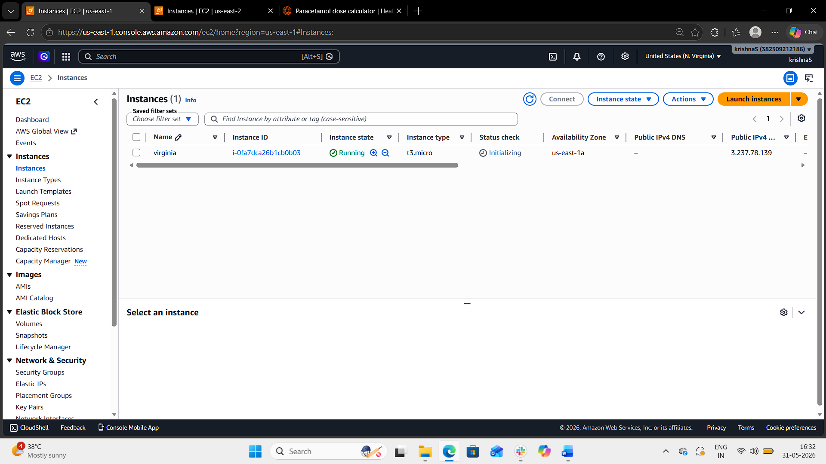
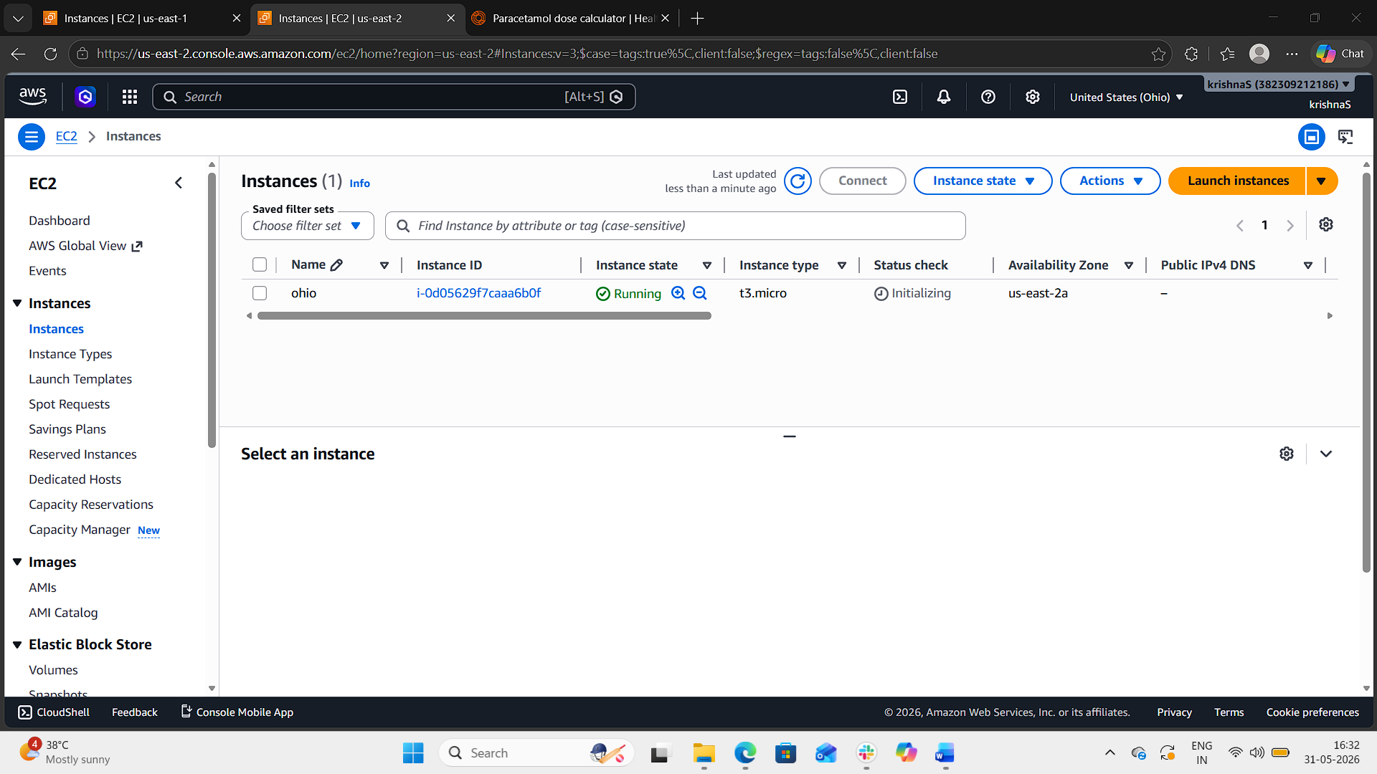
Step 10: Create VPC Peering Connection
- Open Peering Connections.
- Click Create Peering Connection.
- Enter:
- Name: virginia-ohio-peer
- Requester VPC: virginia-vpc
- Accepter Region: Ohio (us-east-2)
- Accepter VPC: ohio-vpc
- Click Create Peering Connection.
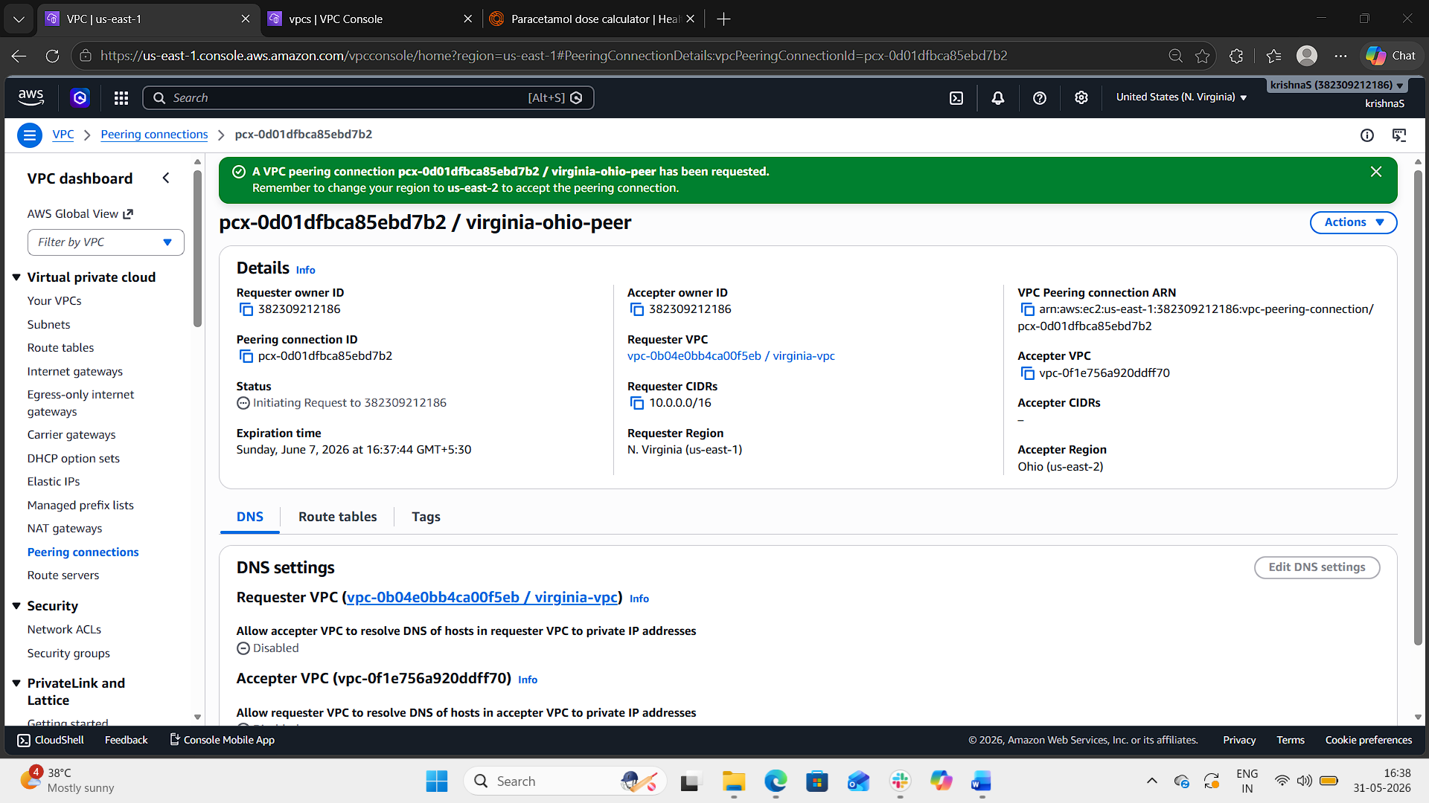
Step 11: Accept Peering Request
- Switch to Ohio region.
- Open Peering Connections.
- Select the pending request.
- Click:
  - Actions → Accept Request
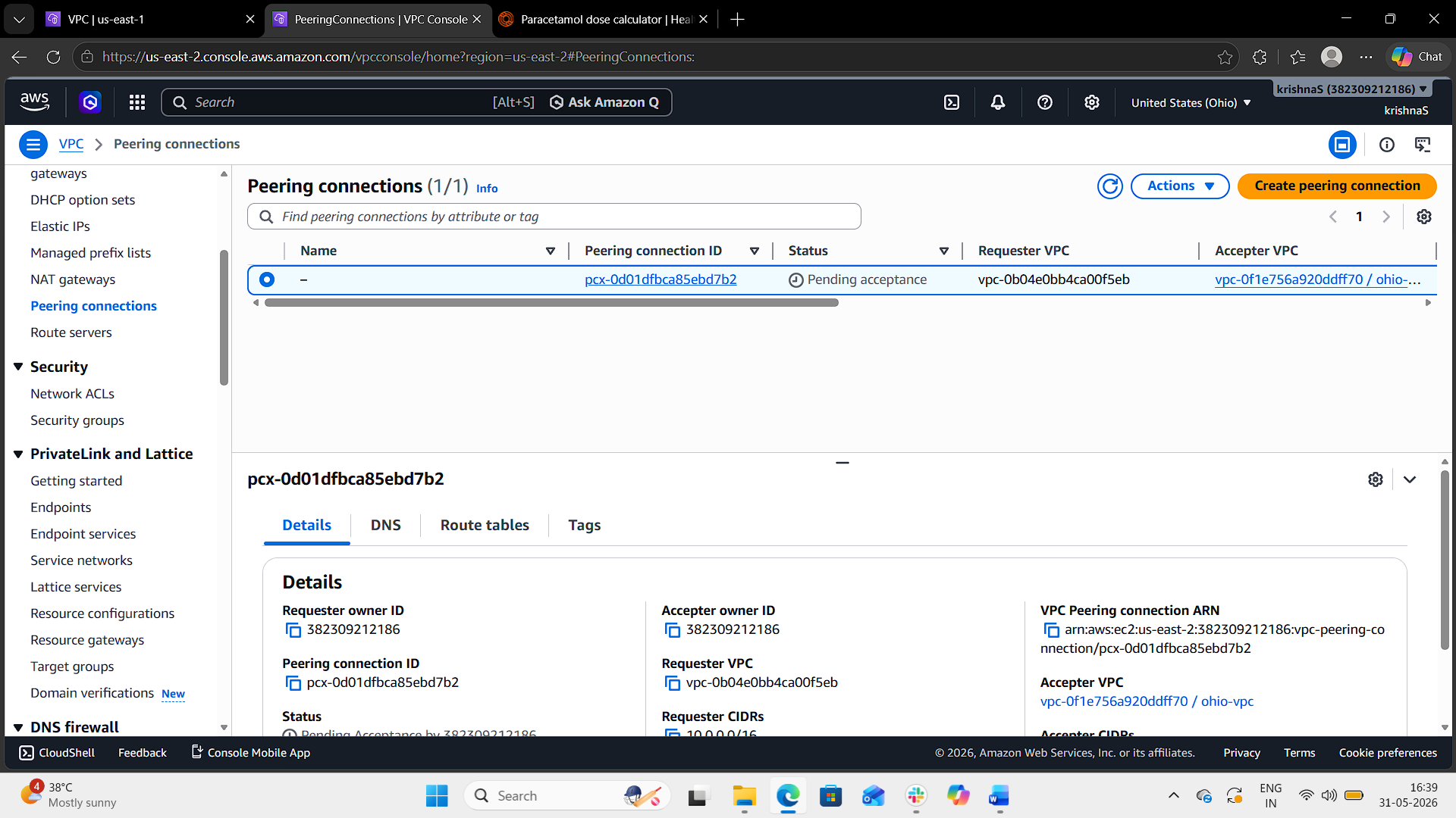
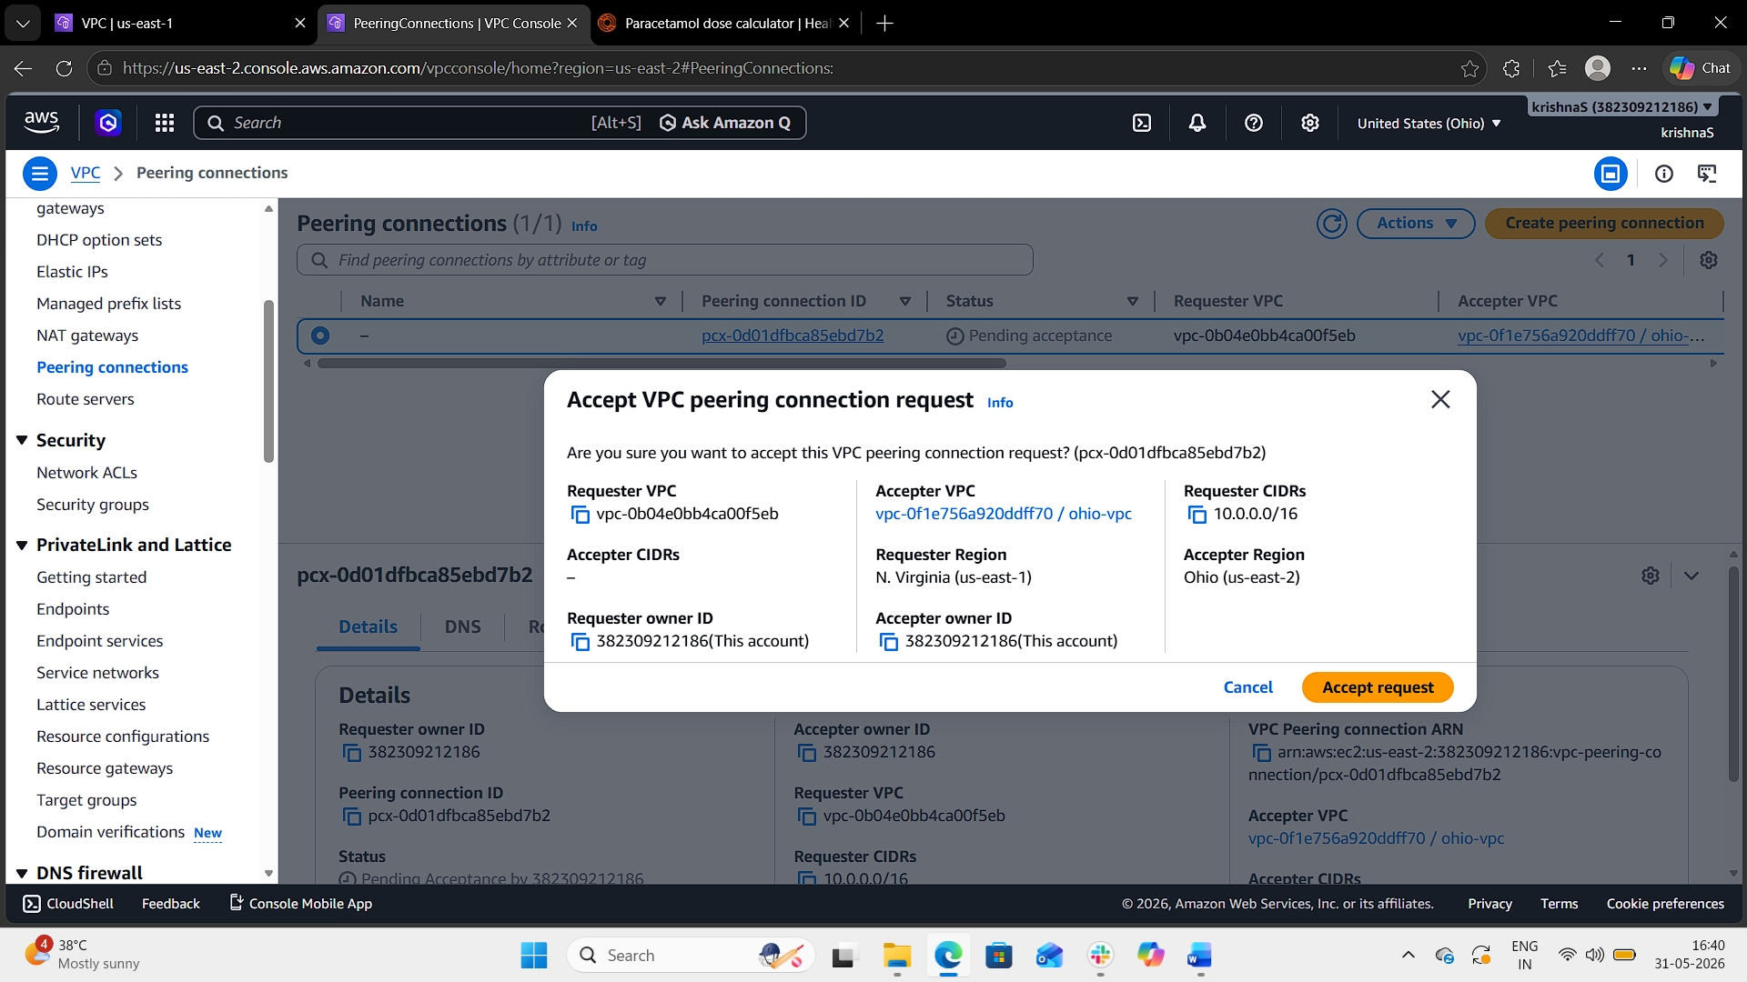
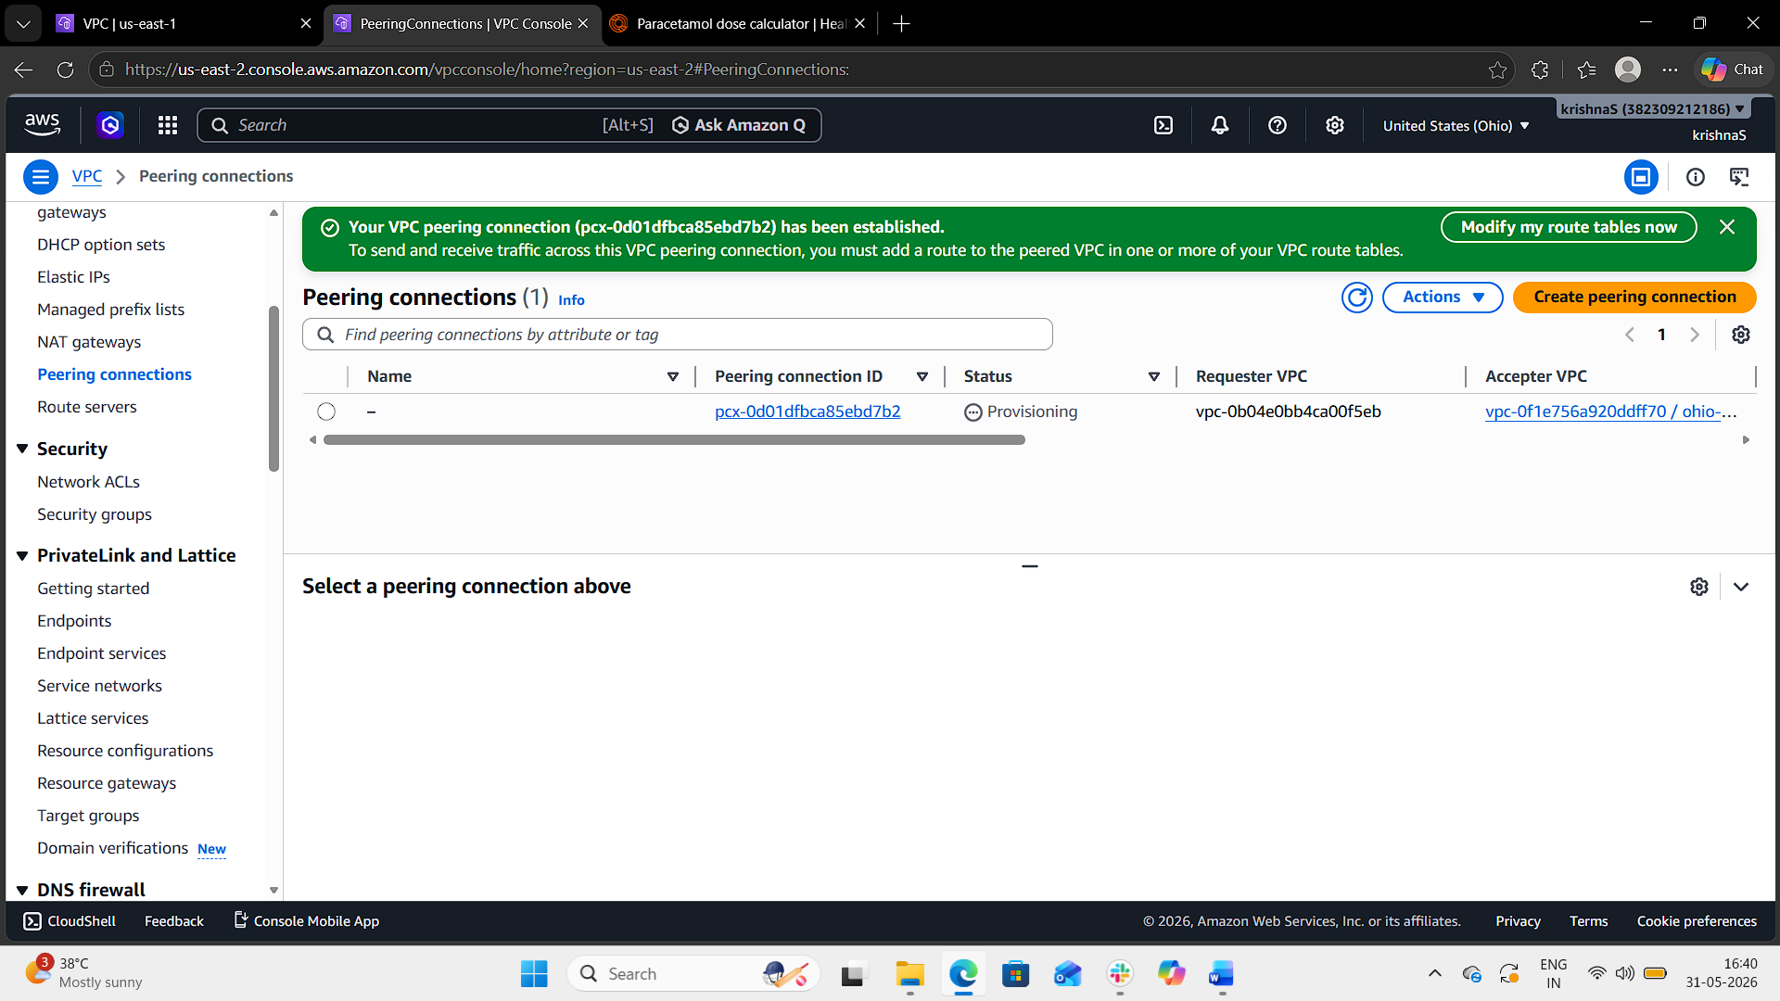
Step 12: Update Route Tables for Peering
Virginia Route Table
Add:
Destination | Target
20.0.0.0/16 | Peering Connection
Ohio Route Table
Add:
Destination | Target
10.0.0.0/16 | Peering Connection
Save changes.
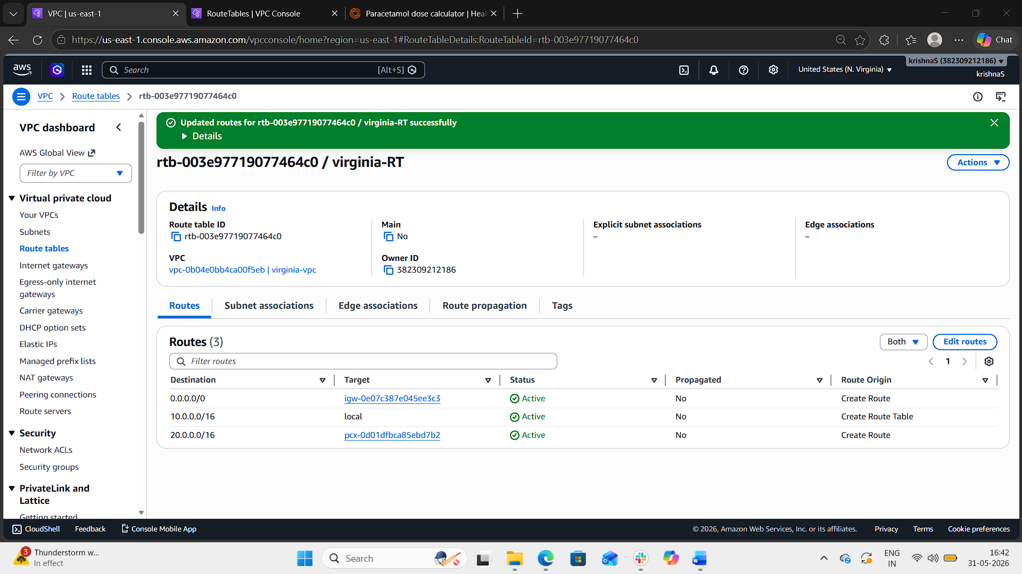
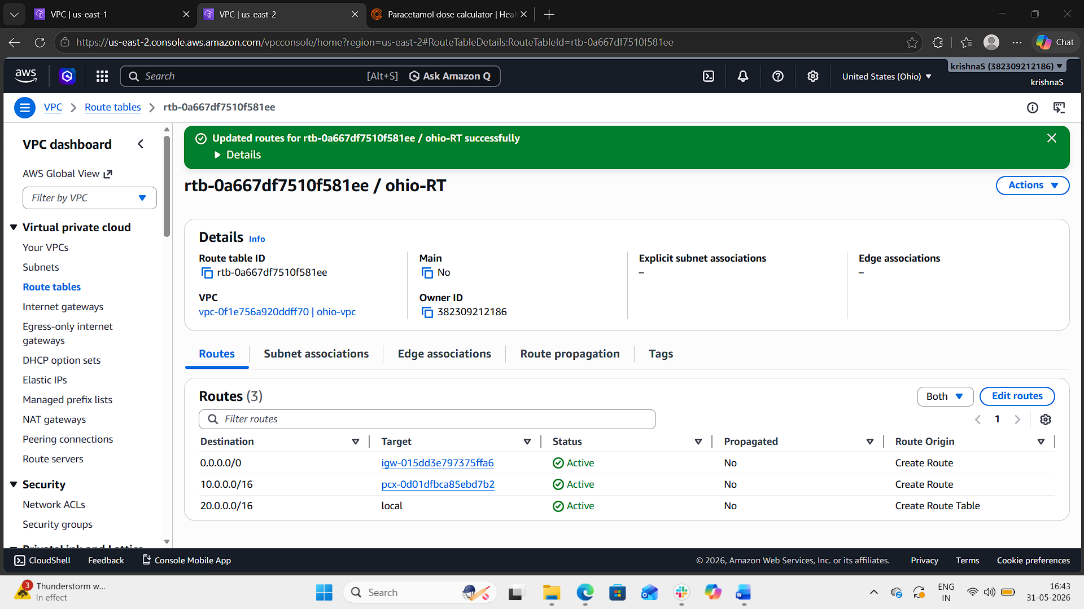
Step 13: Verify VPC Peering
- Connect to Virginia EC2 instance using SSH.
- Obtain the private IP of Ohio EC2.
- Run:
ping <Ohio-Private-IP>
Example:
ping 20.0.1.10
If replies are received, the VPC peering connection is working successfully.
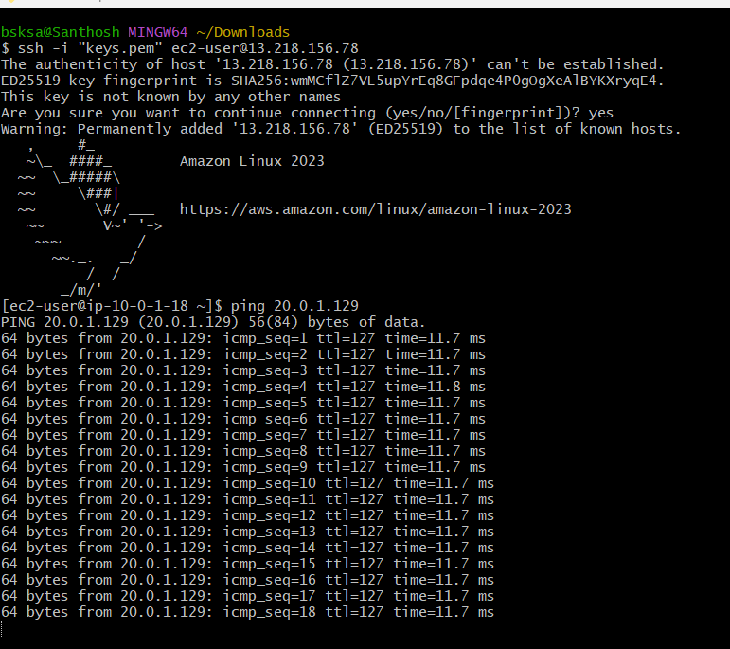

Result
Successfully created:
- VPC in N. Virginia
- VPC in Ohio
- Cross-region VPC peering connection
- EC2 communication using private IP addresses across regions

- Enable VPC peering for cross-account (you can collaborate with your friend to do this task).
To establish VPC peering between two AWS accounts so that resources in different AWS accounts can communicate privately using VPC peering.
Prerequisites
- Two AWS accounts
- One VPC in each account
- Non-overlapping CIDR blocks
- AWS account collaboration with your friend
Example:
Account | Region | VPC CIDR
Account A | us-east-1 | 10.0.0.0/16
Account B | us-east-1 | 20.0.0.0/16

Step 1: Create VPC in Account A
- Login to AWS Management Console using Account A.
- Open Amazon VPC.
- Go to Your VPCs → Create VPC.
- Select:
  - VPC only
- Enter:
  - Name: accountA-vpc
  - CIDR: 10.0.0.0/16
- Click Create VPC.
Step 2: Create VPC in Account B
- Login using Account B.
- Open VPC Dashboard.
- Create another VPC.
- Enter:
- Name: accountB-vpc
- CIDR: 20.0.0.0/16
- Click Create VPC.
Step 3: Create Subnets
Create one subnet in each VPC.
Account A
- Subnet CIDR: 10.0.1.0/24
Account B
- Subnet CIDR: 20.0.1.0/24
Step 4: Create VPC Peering Request
Login to Account A.
- Open Peering Connections
- Click Create Peering Connection
- Enter:
- Name: cross-account-peer
- Requester VPC: accountA-vpc
- Accepter Account: Another account
- AWS Account ID: Friend’s AWS Account ID
- Accepter Region: same region
- Accepter VPC ID: Friend’s VPC ID
- Click Create Peering Connection
Step 5: Accept Peering Request in Account B
Login to Account B.
- Open Peering Connections
- Select pending request
- Click:
  - Actions → Accept Request

Step 6: Update Route Tables
In Account A
- Open Route Tables
- Select route table for accountA-vpc
- Add route:
Destination | Target
20.0.0.0/16 | Peering Connection
- Save changes.
In Account B
- Open Route Tables
- Select route table for accountB-vpc
- Add route:
Destination | Target
10.0.0.0/16 | Peering Connection
- Save changes.
Step 7: Configure Security Groups
In both accounts, allow:
- SSH (22)
- All ICMP IPv4
Example:
Type | Source
SSH | 0.0.0.0/0
All ICMP IPv4 | 0.0.0.0/0

Step 8: Launch EC2 Instances
Launch one EC2 instance in each VPC using Amazon EC2.
Enable:
- Public IP
- Correct VPC and subnet selection
Step 9: Verify Cross-Account Peering
- SSH into one EC2 instance.
- Ping the private IP of the EC2 instance in the other AWS account.
Example:
ping 20.0.1.10
- Set up a VPC Transit Gateway.
Objective
To configure AWS Transit Gateway for communication between two VPCs in the same AWS region.

Step 1: Create VPC 1
- Login to AWS Management Console
- Open Amazon VPC
- Select region:
  - N. Virginia (us-east-1)
- Go to:
  - Your VPCs → Create VPC
- Enter:
  - VPC only
  - Name: vpc-1
  - CIDR Block: 10.0.0.0/16
- Click:
  - Create VPC
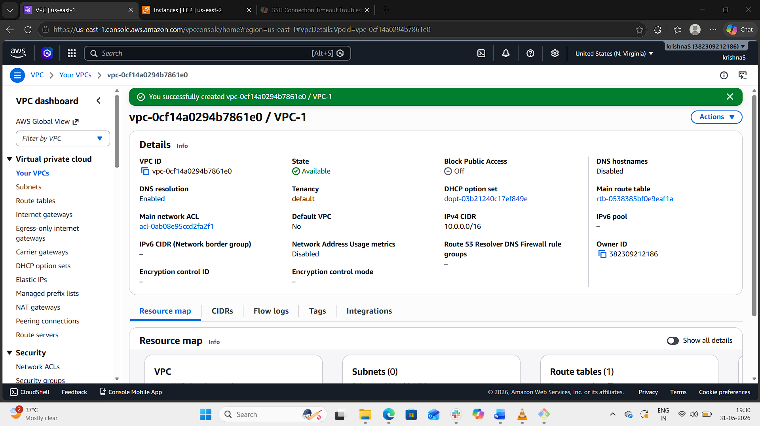
Step 2: Create Subnet for VPC 1
- Open:
  - Subnets → Create subnet
- Enter:
  - VPC: vpc-1
  - Subnet Name: subnet-1
  - AZ: us-east-1a
  - CIDR: 10.0.1.0/24
- Click:
  - Create subnet
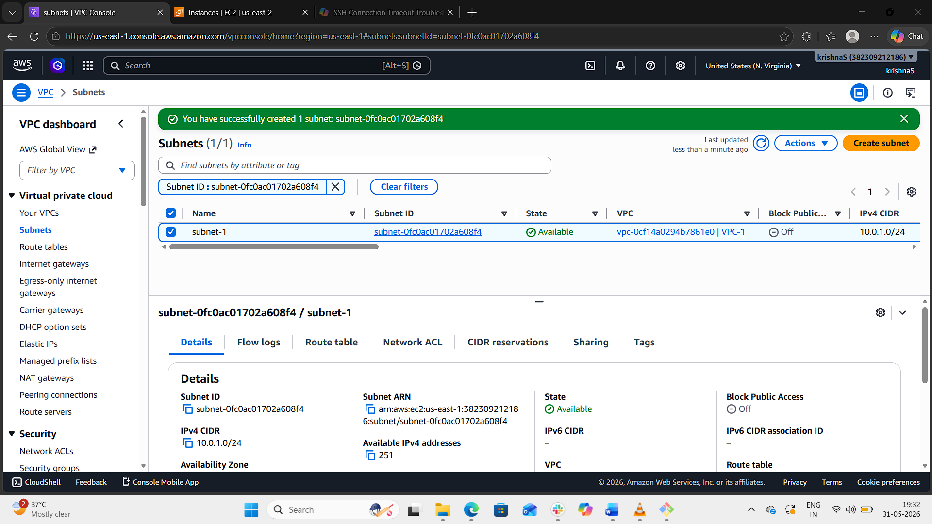
Step 3: Create VPC 2
- Go to:
  - Your VPCs → Create VPC
- Enter:
  - Name: vpc-2
  - CIDR: 20.0.0.0/16
- Create VPC.
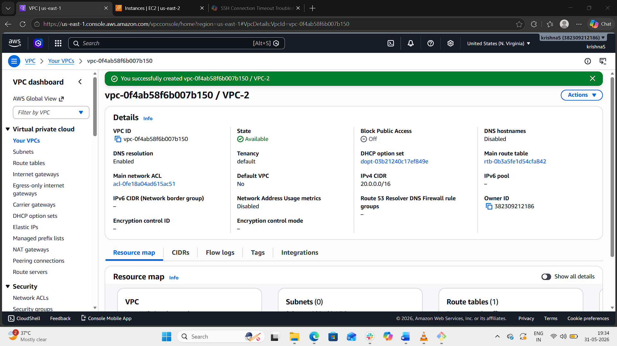
Step 4: Create Subnet for VPC 2
- Open:
  - Subnets → Create subnet
- Enter:
  - VPC: vpc-2
  - Subnet Name: subnet-2
  - AZ: us-east-1b
  - CIDR: 20.0.1.0/24
- Click:
  - Create subnet
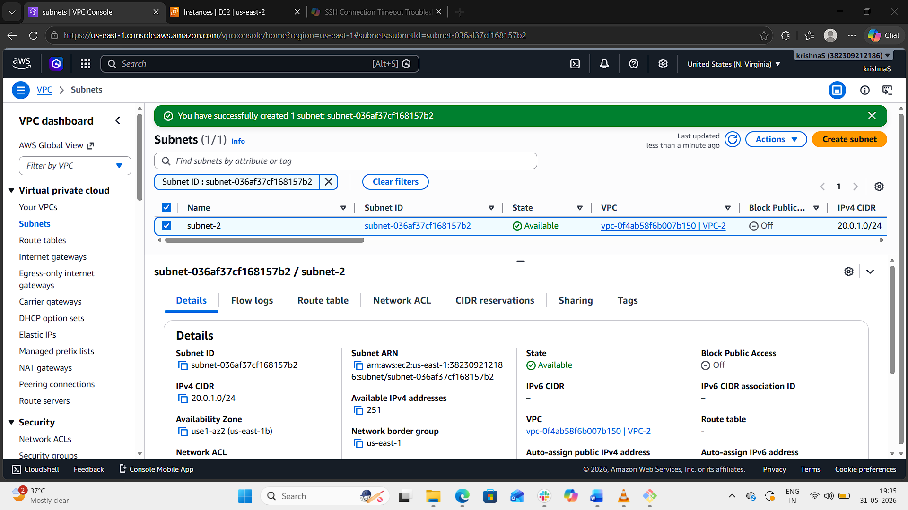
Step 5: Create Internet Gateway for Both VPCs
For VPC 1
- Open:
  - Internet Gateways
- Click:
  - Create internet gateway
- Name:
  - igw-vpc1
- Attach to:
  - vpc-1
For VPC 2
Repeat:
- Create igw-vpc2
- Attach to vpc-2
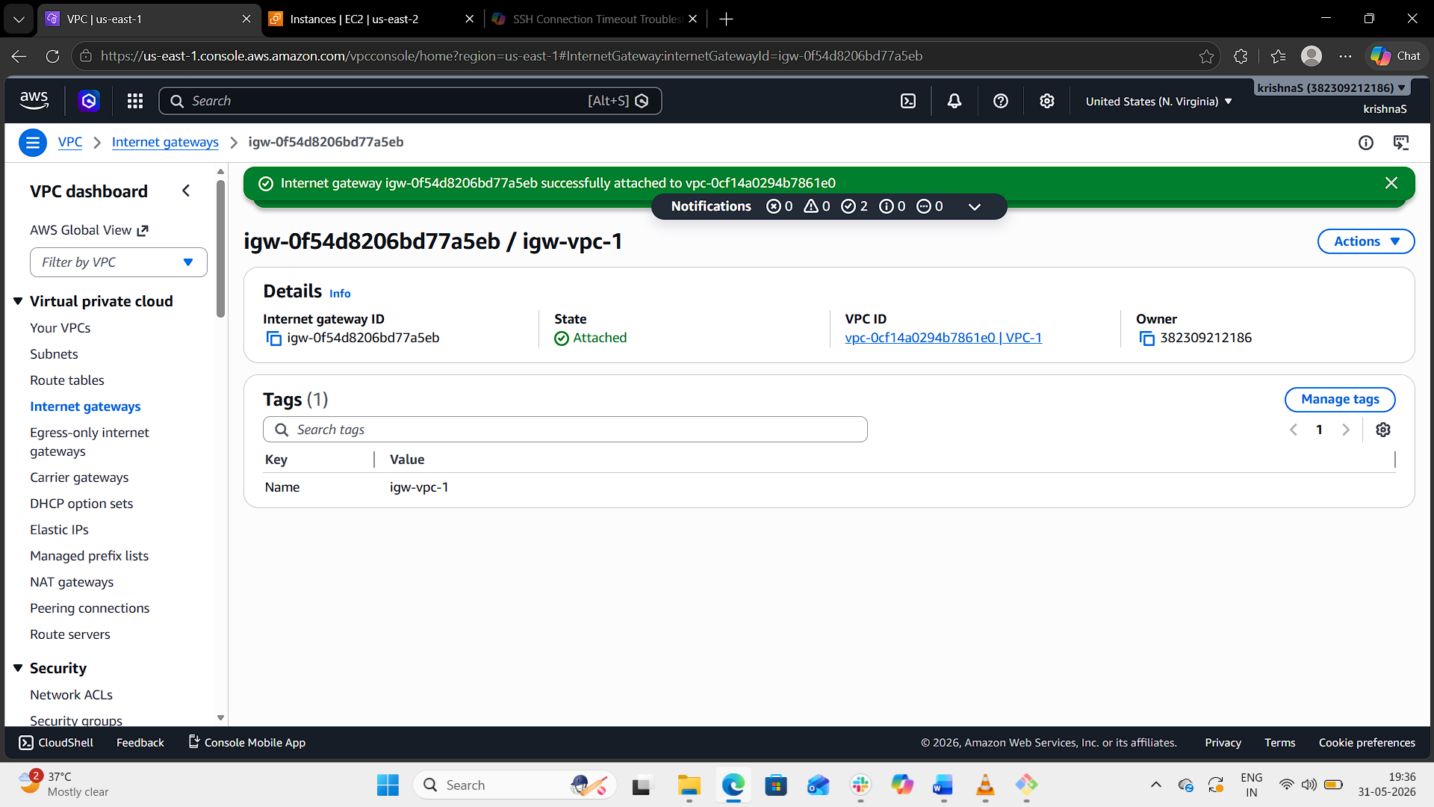
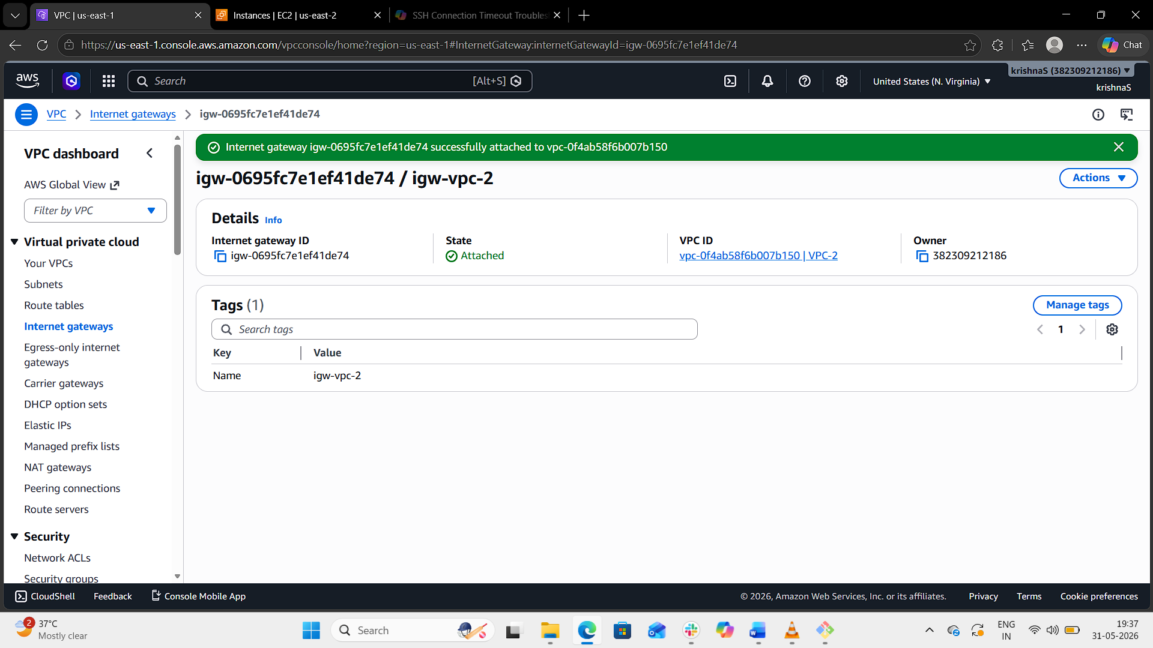
Step 6: Update Route Tables for Internet Access
VPC 1 Route Table
Add:
Destination | Target
0.0.0.0/0 | Internet Gateway
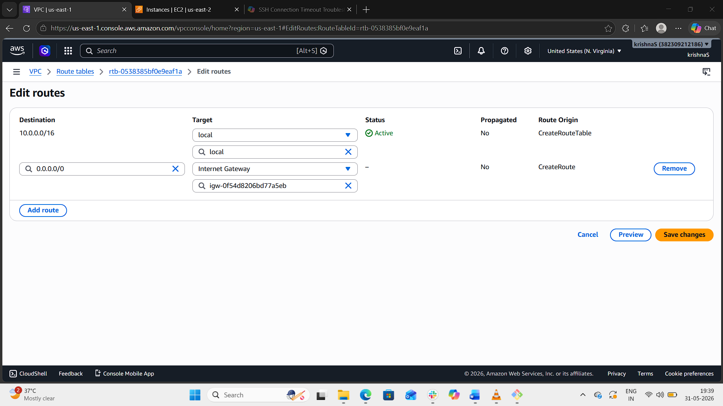
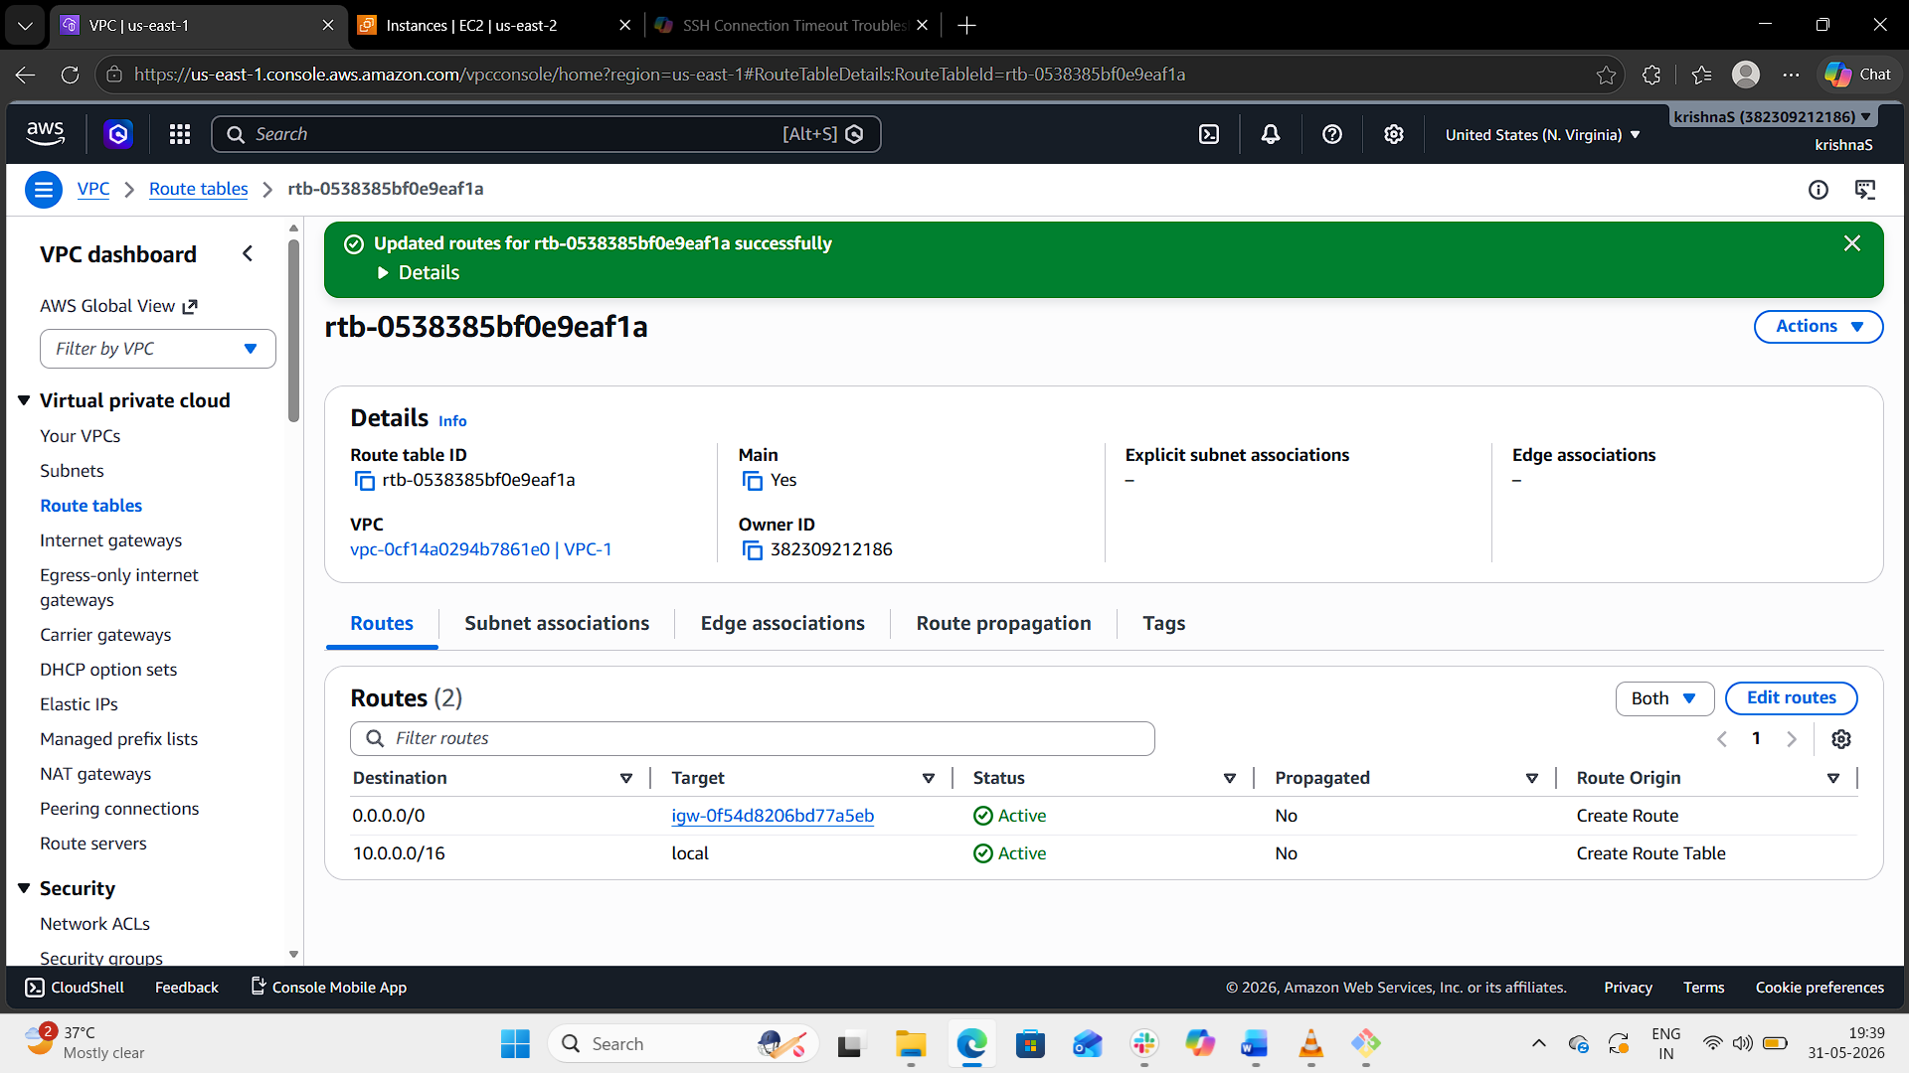

VPC 2 Route Table
Add:
Destination | Target
0.0.0.0/0 | Internet Gateway
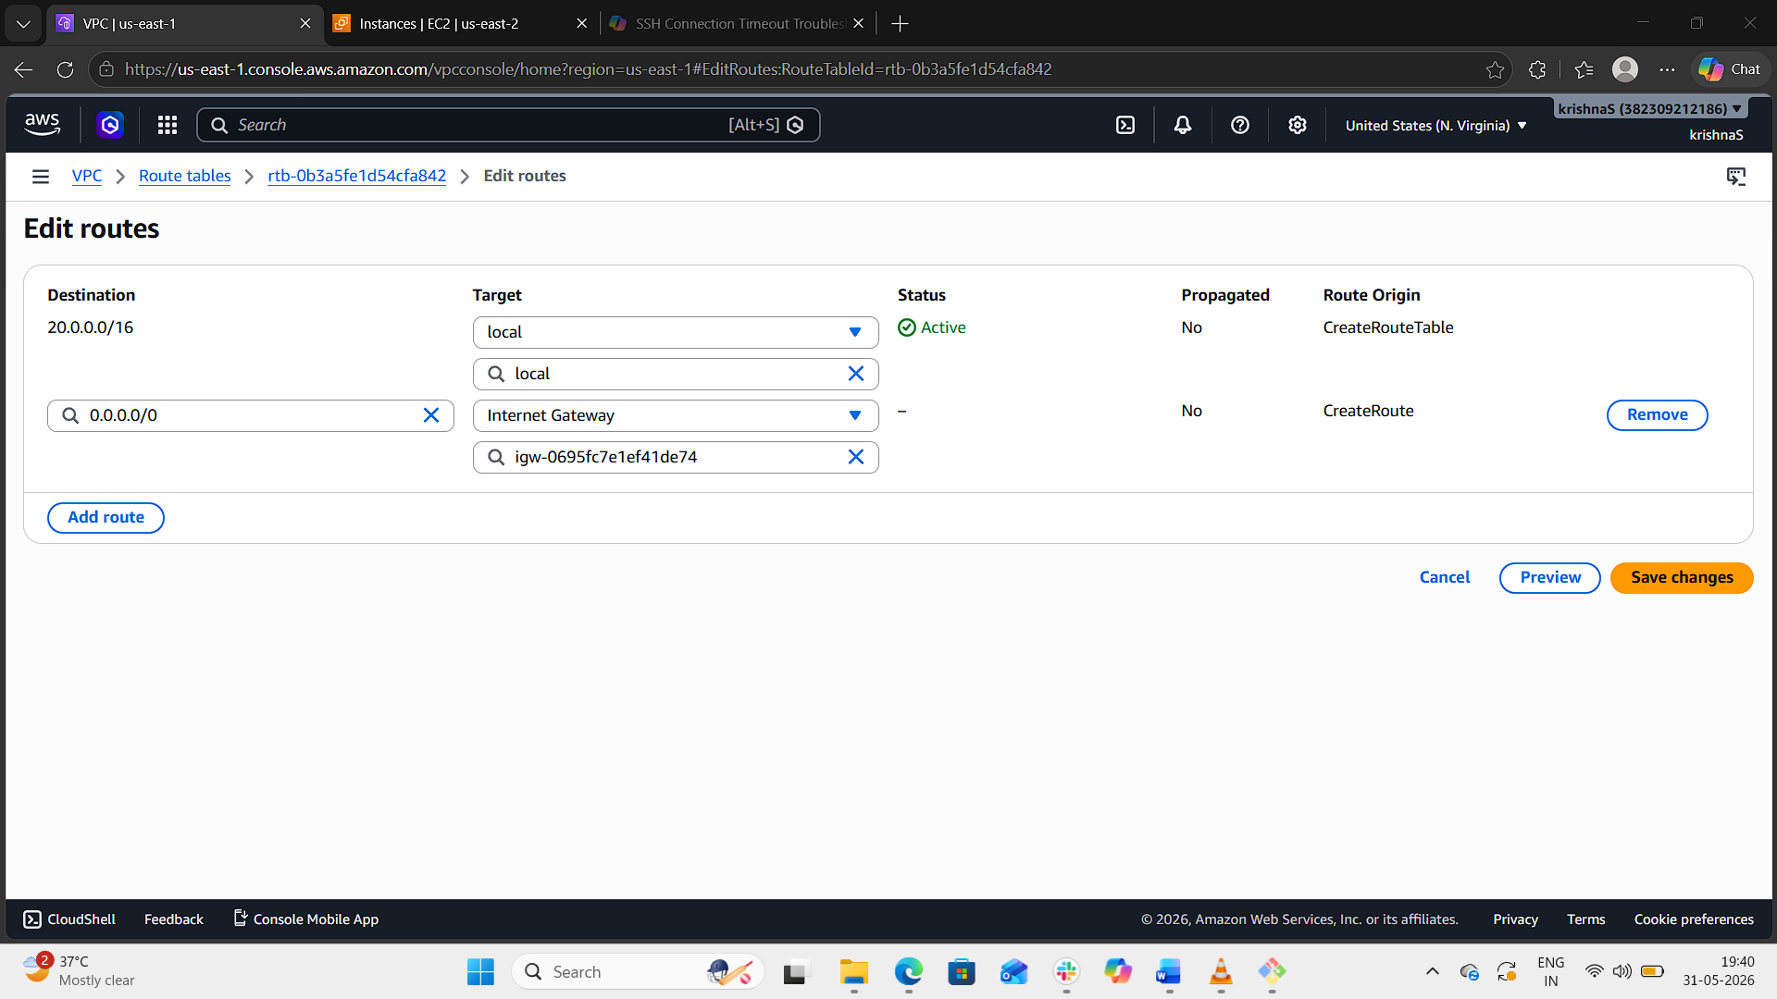
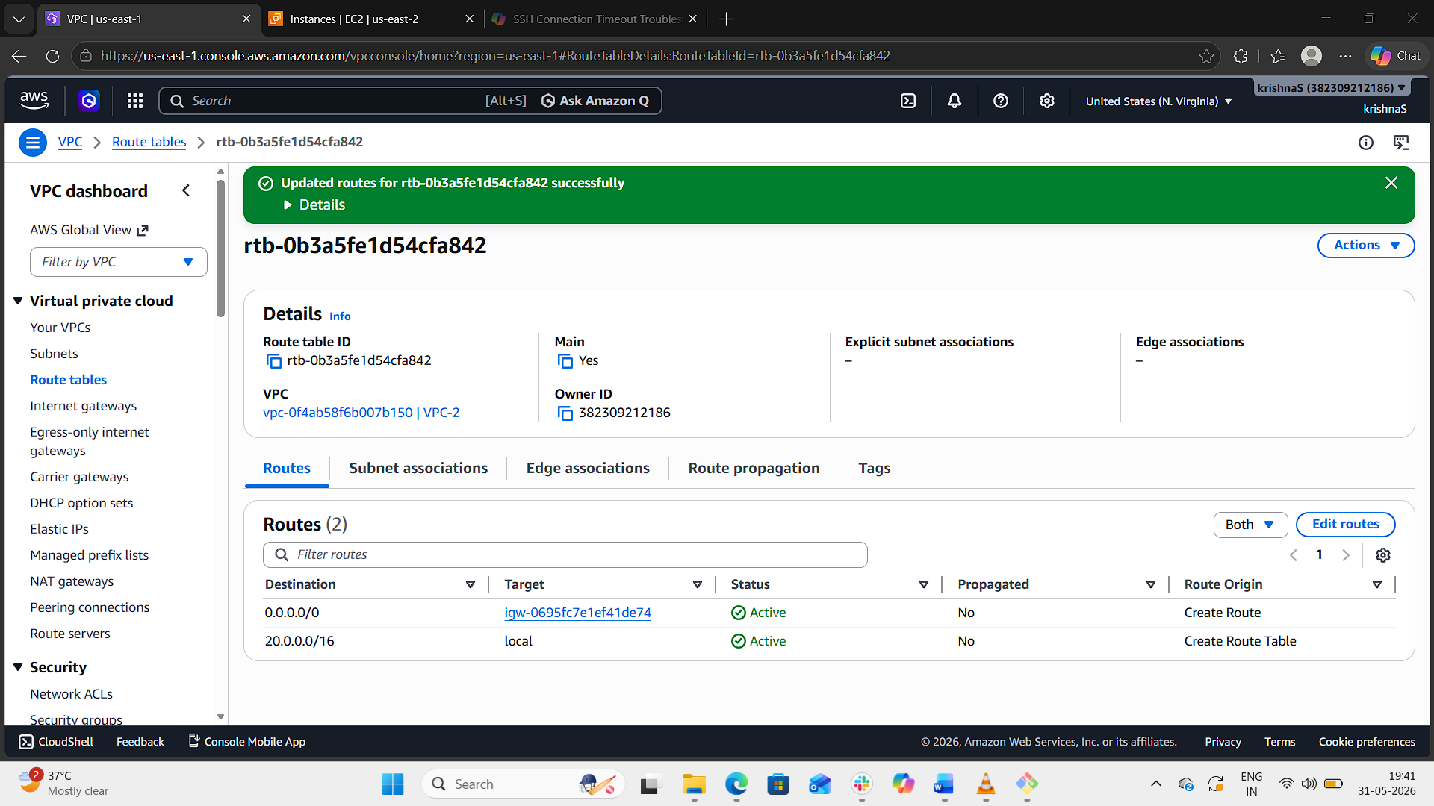
Step 7: Launch EC2 Instances
Using Amazon EC2, launch one EC2 instance in each VPC.
EC2 in VPC 1
- VPC: vpc-1
- Subnet: subnet-1
- Auto-assign Public IP: Enabled
EC2 in VPC 2
- VPC: vpc-2
- Subnet: subnet-2
- Auto-assign Public IP: Enabled
Security Group:
- SSH (22)
- All ICMP IPv4
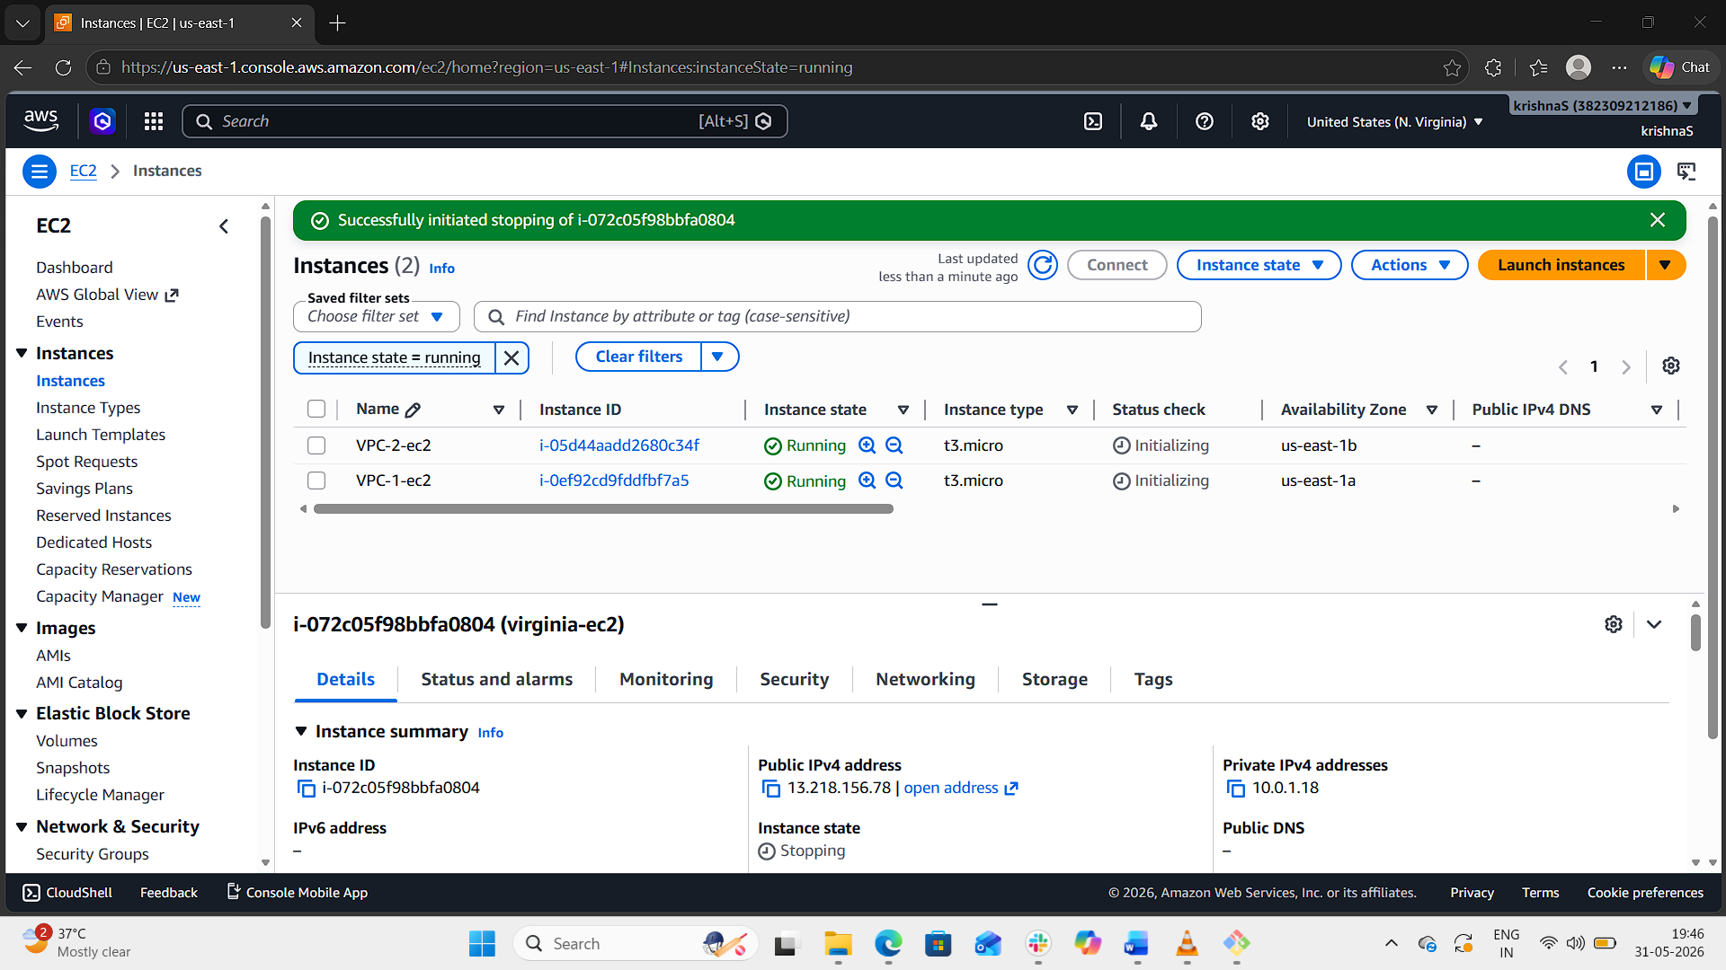

Step 8: Create Transit Gateway
- Open:
  - Transit Gateways
- Click:
  - Create Transit Gateway
- Enter:
  - Name: main-tgw
- Leave default settings.
- Click:
  - Create Transit Gateway
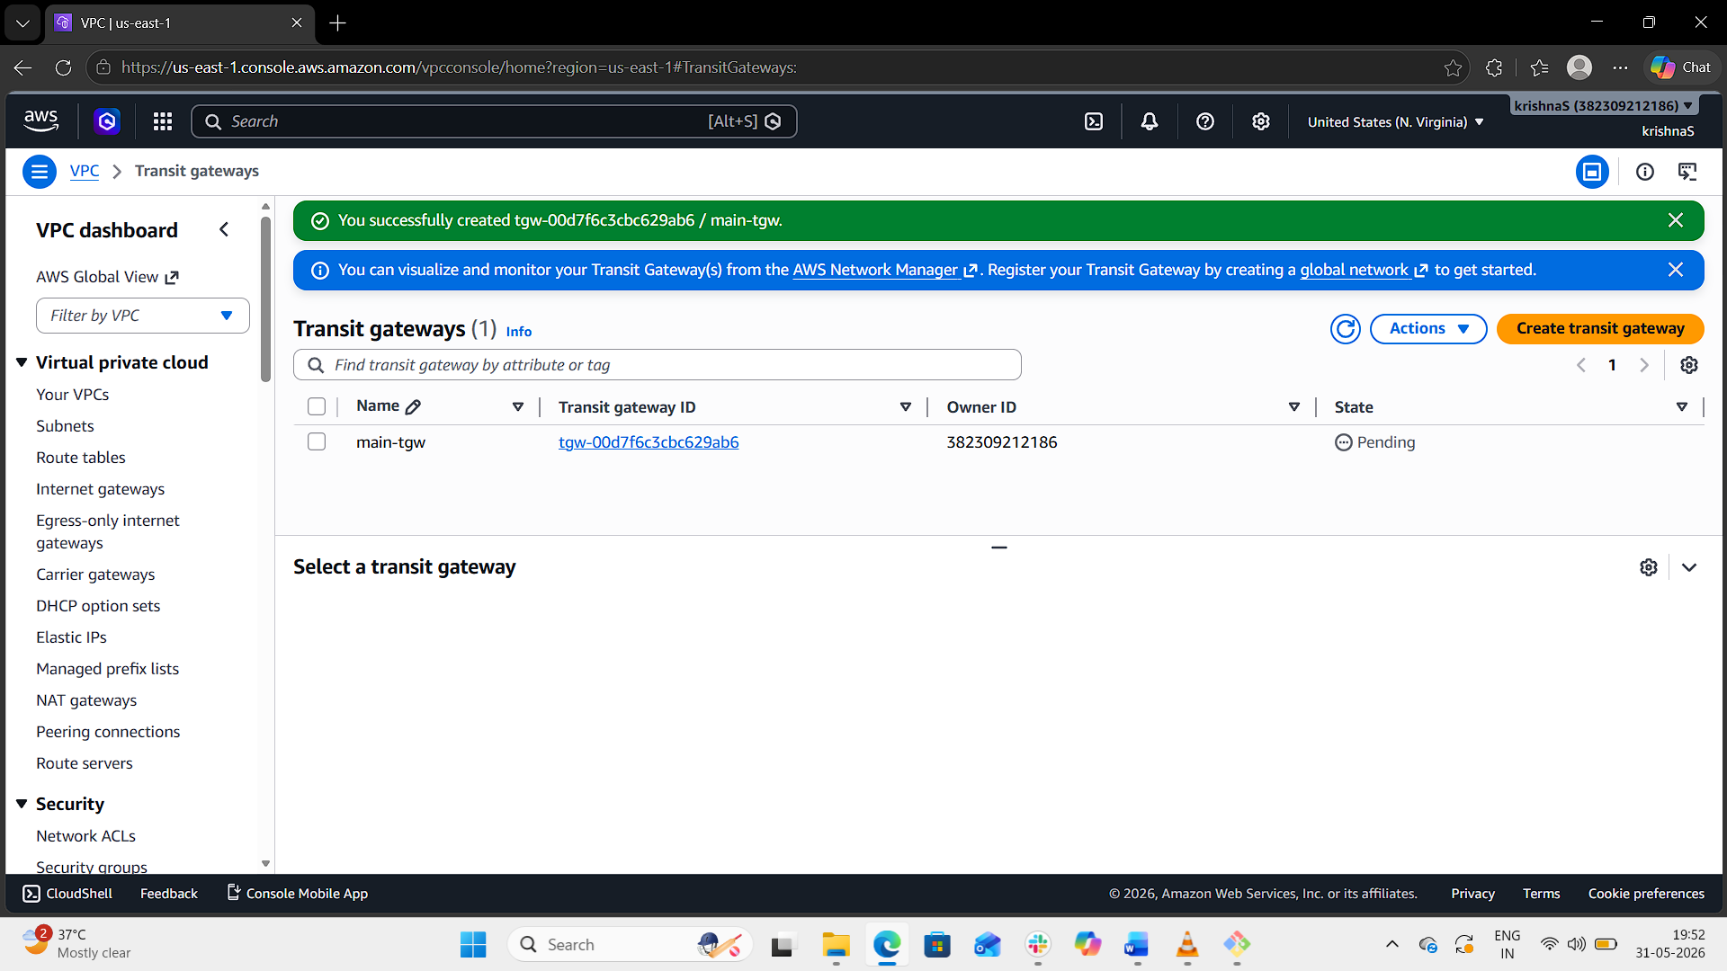
Step 9: Attach VPC 1 to Transit Gateway
- Open:
  - Transit Gateway Attachments
- Click:
  - Create Transit Gateway Attachment
- Enter:
  - Transit Gateway: main-tgw
  - Attachment Type: VPC
  - VPC ID: vpc-1
  - Select subnet: subnet-1
- Click:
  - Create attachment
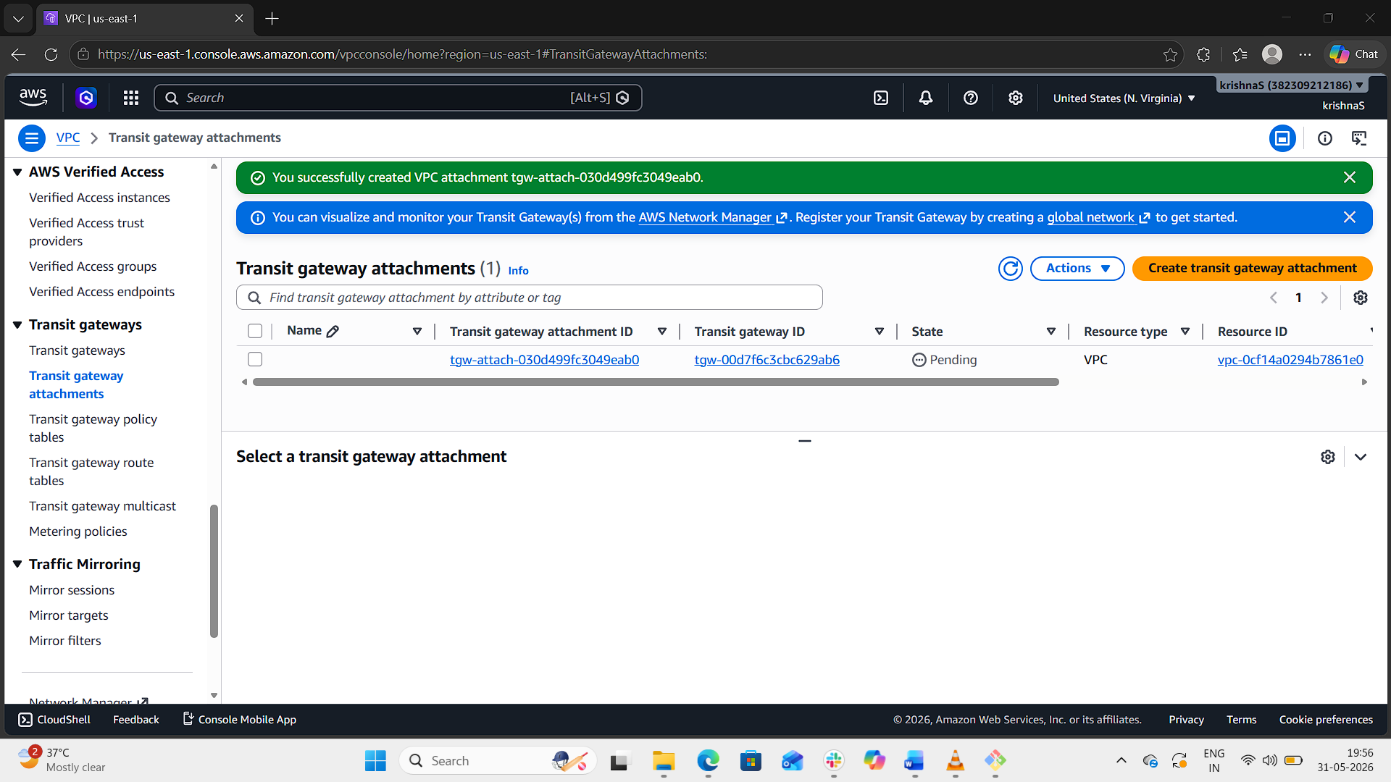
Step 10: Attach VPC 2 to Transit Gateway
Repeat the same steps:
- Select vpc-2
- Select subnet-2
Create attachment.
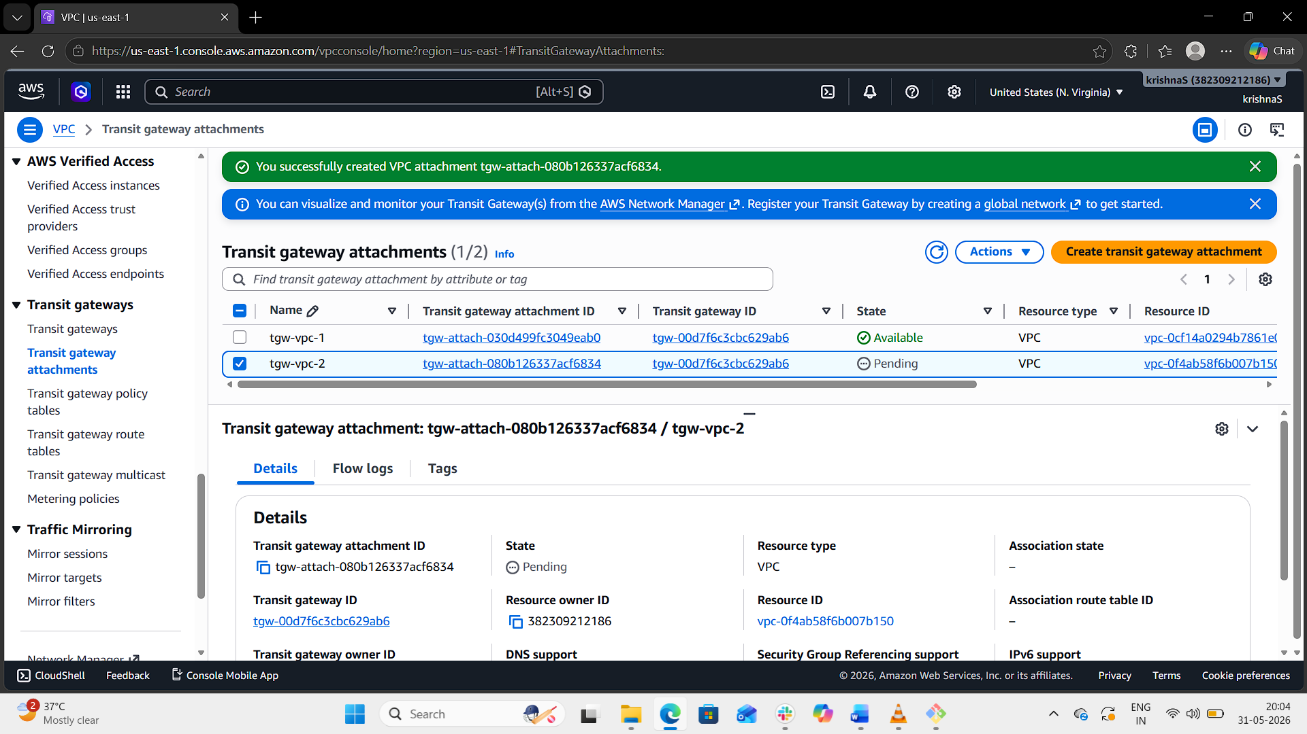

Step 11: Update Route Tables for Transit Gateway
VPC 1 Route Table
Add:
Destination | Target
20.0.0.0/16 | Transit Gateway
Save changes.
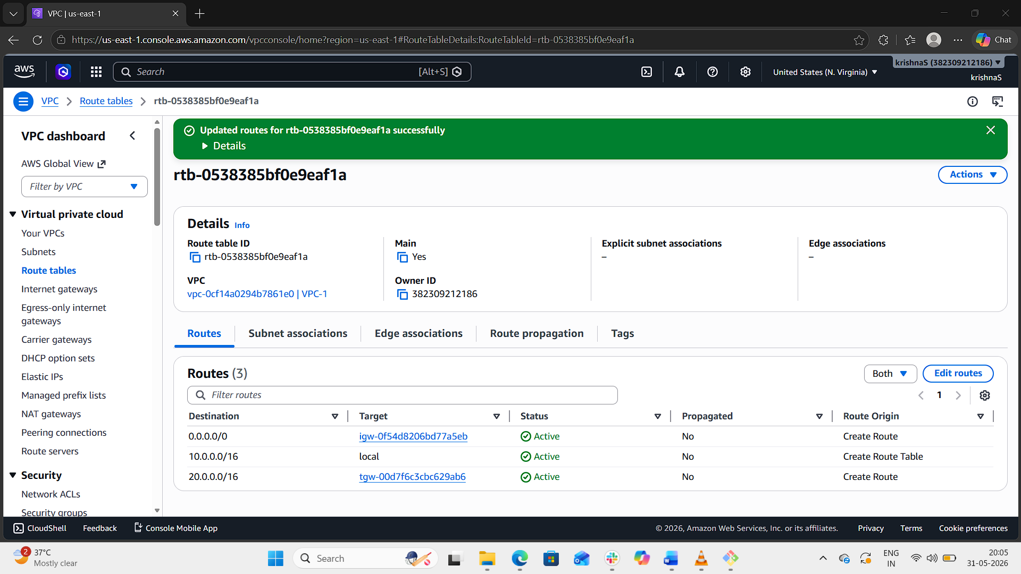
VPC 2 Route Table
Add:
Destination | Target
10.0.0.0/16 | Transit Gateway
Save changes.
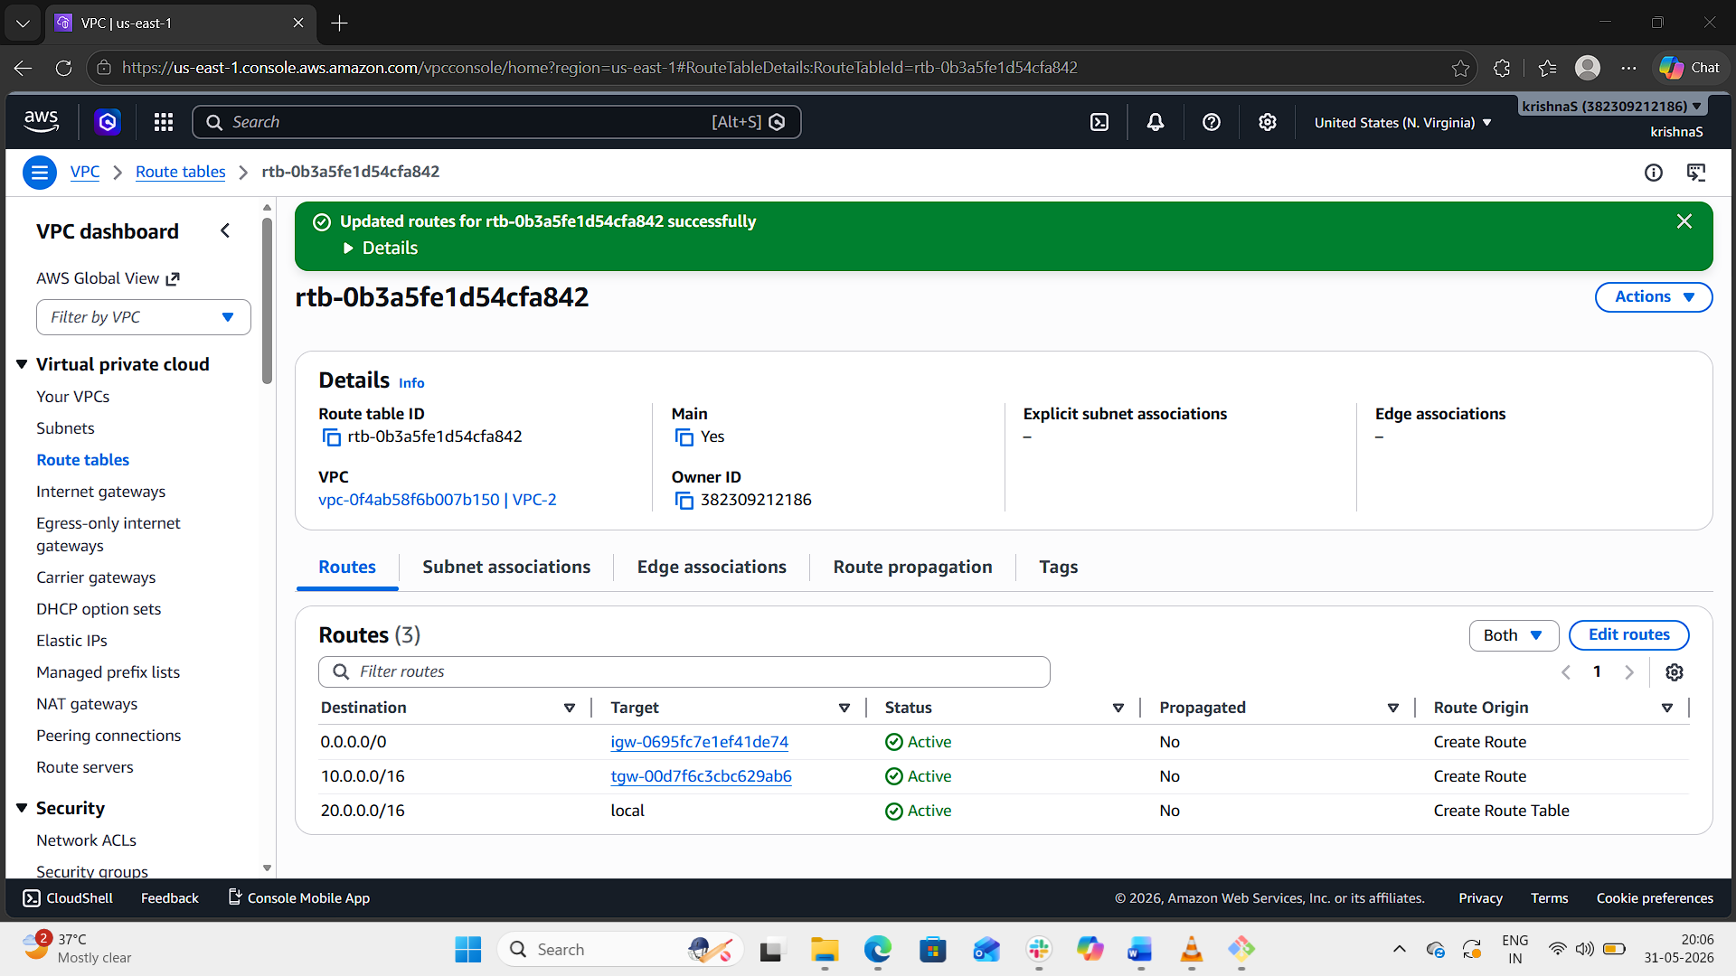
Step 12: Verify Connectivity
- SSH into EC2 instance in VPC 1.
- Ping private IP of EC2 in VPC 2.
Example:
ping 20.0.1.10
If ping replies are received, Transit Gateway setup is successful.
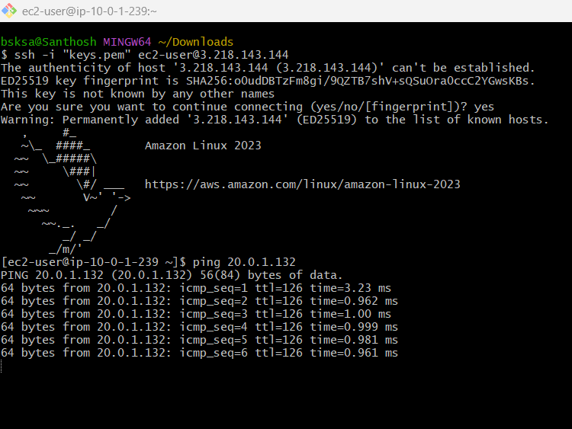
Result
Successfully configured:
- Two VPCs in same region
- AWS Transit Gateway
- Transit Gateway attachments
- Route table configuration
- Private communication between VPCs through Transit Gateway

- Set up a VPC Endpoint.
To configure a VPC Endpoint in AWS for private communication between an EC2 instance and Amazon S3 without using the public internet.
Step 1: Create VPC
- Login to AWS Management Console.
- Open Amazon VPC.
- Go to Your VPCs and click Create VPC.
- Select VPC only.
- Enter:
  - VPC Name: endpoint-vpc
  - IPv4 CIDR Block: 10.0.0.0/16
- Click Create VPC.
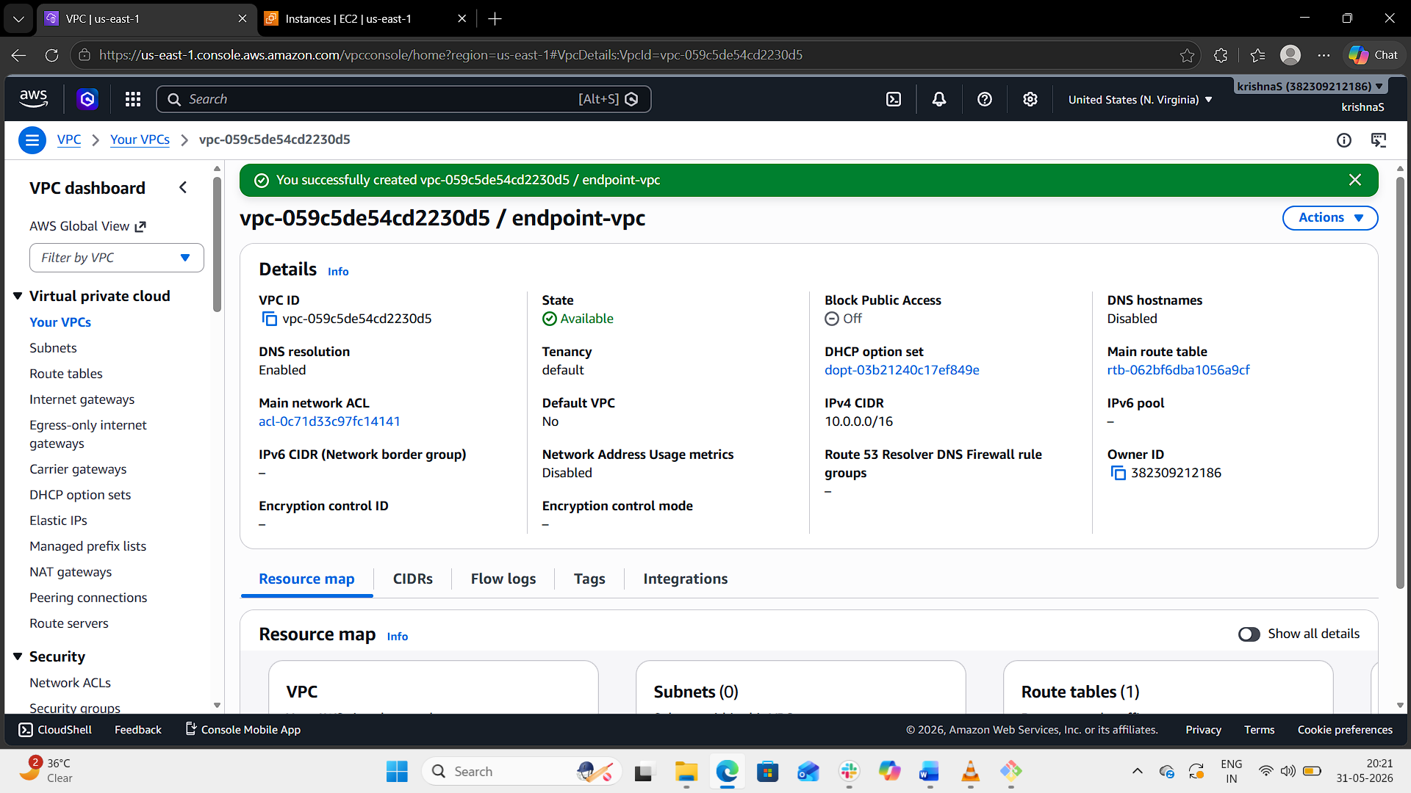
Step 2: Create Subnet
- Open Subnets.
- Click Create subnet.
- Select VPC:
  - endpoint-vpc
- Enter:
  - Subnet Name: endpoint-subnet
  - Availability Zone: us-east-1a
  - CIDR Block: 10.0.1.0/24
- Click Create subnet.
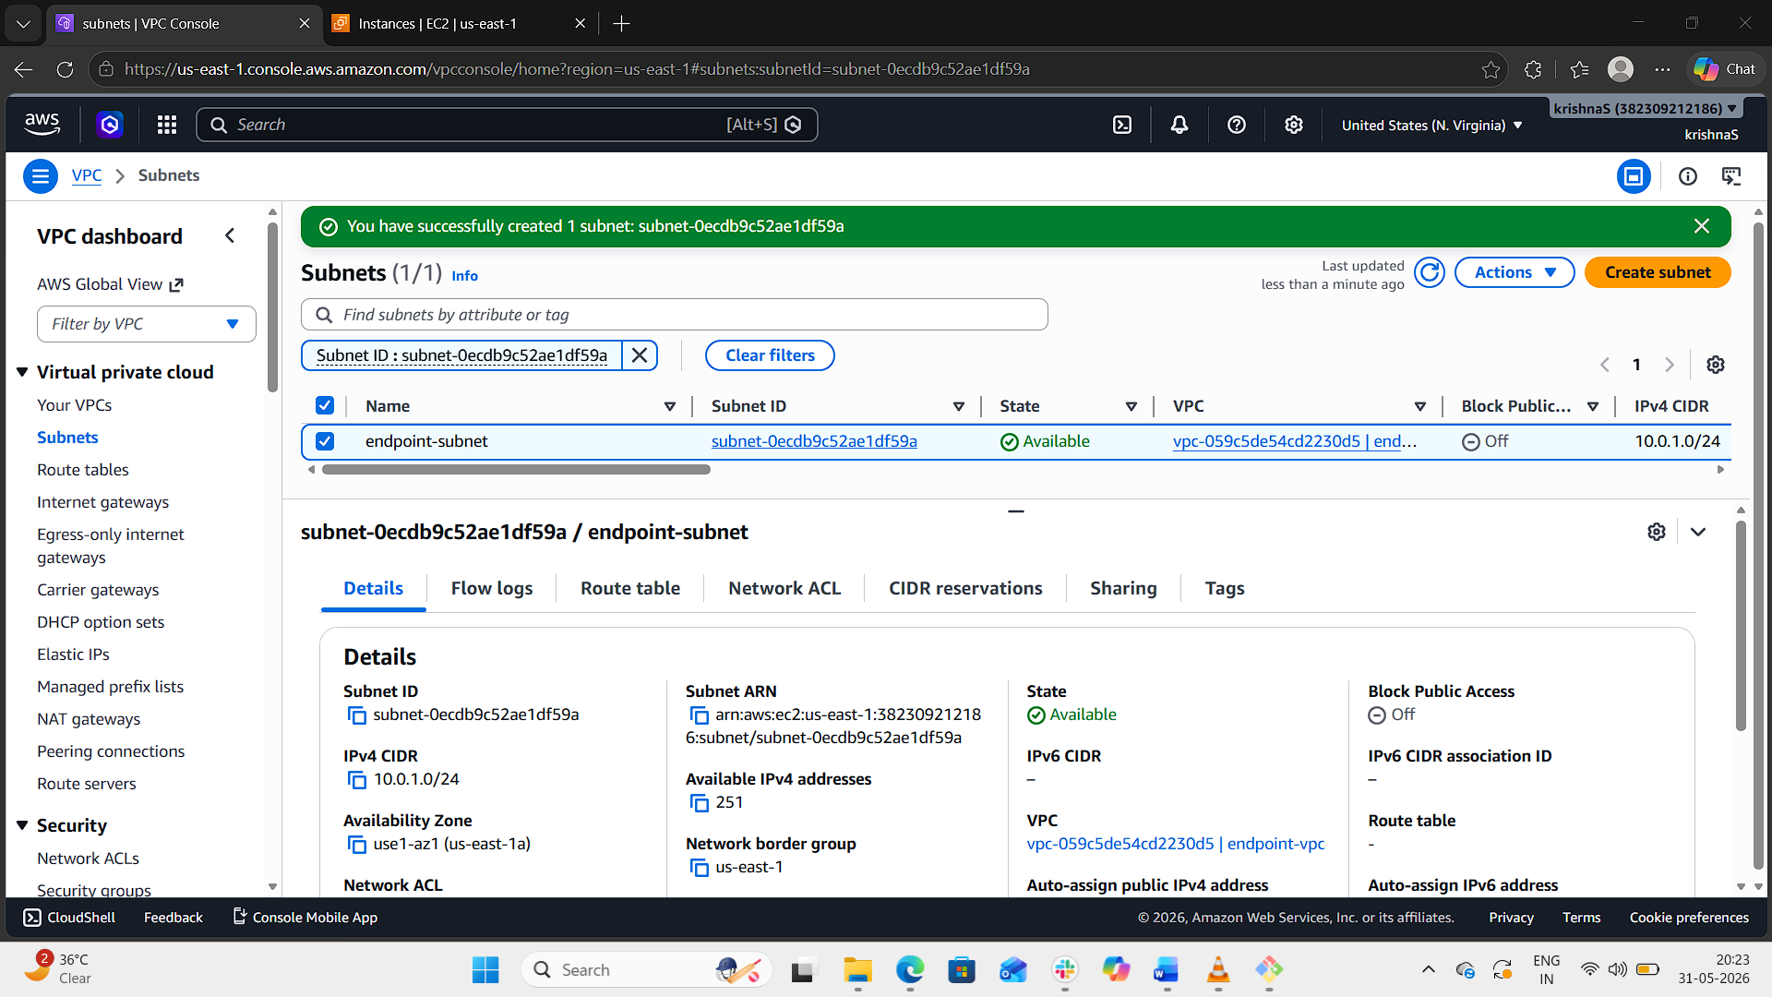
Step 3: Create Internet Gateway
- Open Internet Gateways.
- Click Create internet gateway.
- Enter:
  - Name: endpoint-igw
- Click Create internet gateway.
- Select the IGW.
- Click:
  - Actions → Attach to VPC
- Select:
  - endpoint-vpc
- Click:
  - Attach internet gateway
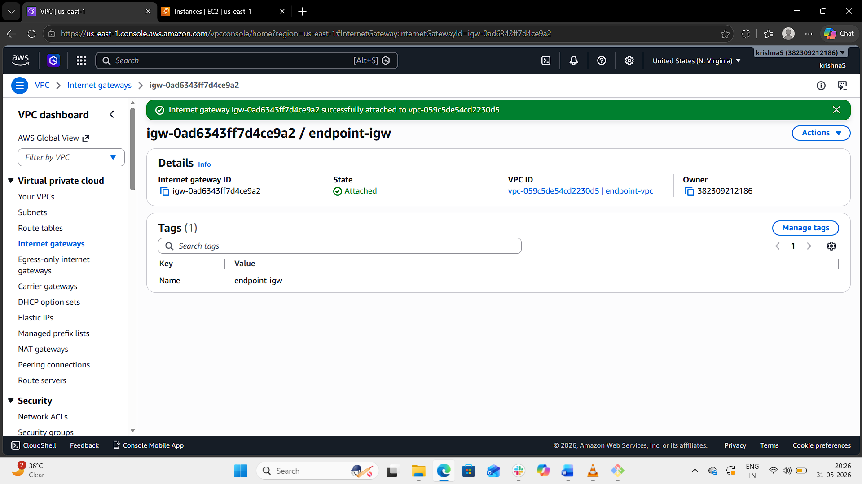
Step 4: Create Route Table
- Open Route Tables.
- Click Create route table.
- Enter:
  - Name: endpoint-rt
  - VPC: endpoint-vpc
- Click Create route table.
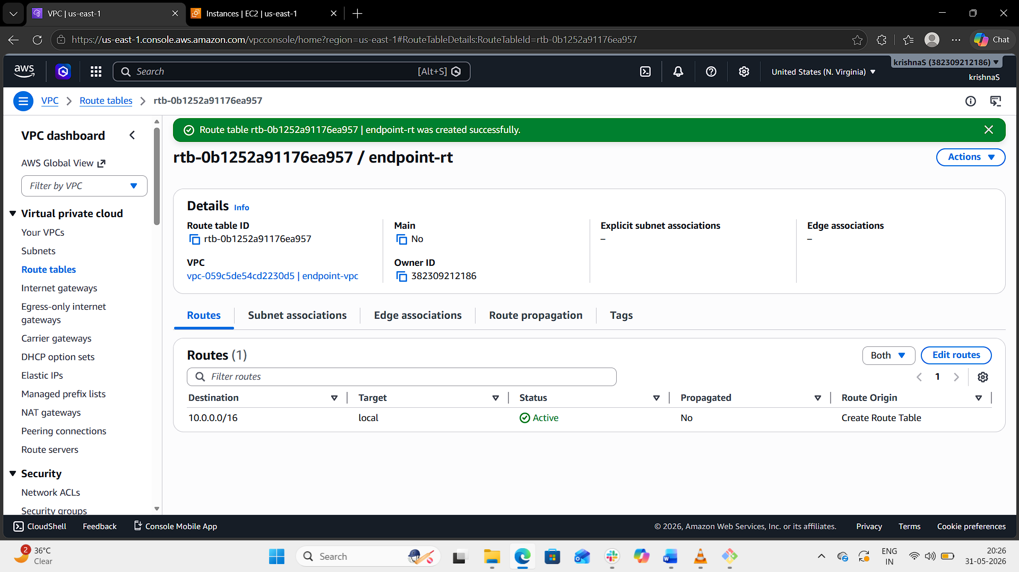
Step 5: Add Internet Route
- Select endpoint-rt.
- Open the Routes tab.
- Click Edit routes.
- Add route:
Destination | Target
0.0.0.0/0 | Internet Gateway
- Save changes.
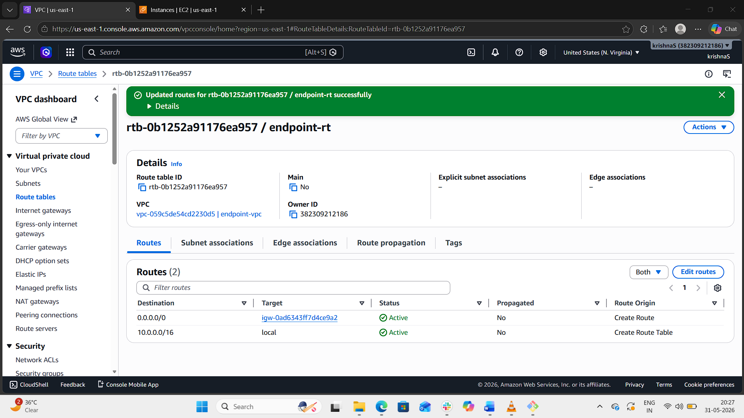
Step 6: Associate Route Table with Subnet
- Open Subnet Associations tab.
- Click Edit subnet associations.
- Select:
  - endpoint-subnet
- Click:
  - Save associations
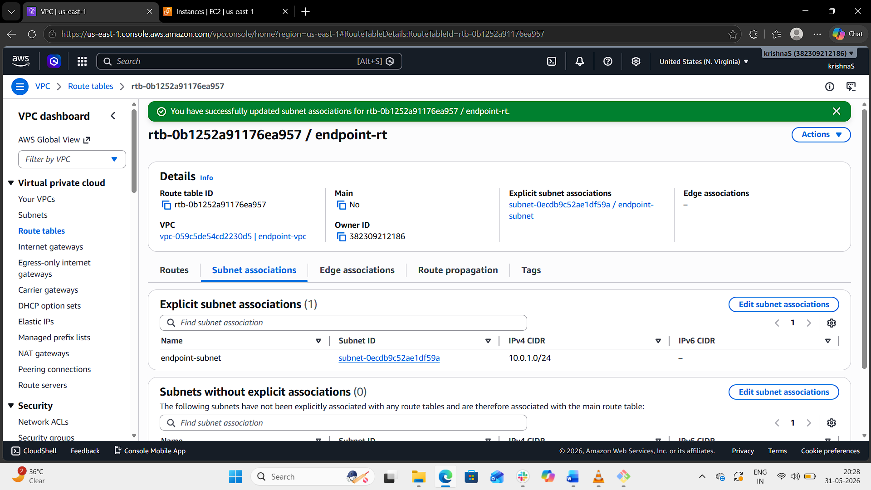
Step 7: Launch EC2 Instance
Using Amazon EC2:
- Open Instances.
- Click Launch Instance.
Enter:
- Name: endpoint-ec2
- AMI: Amazon Linux 2
- Instance Type: t2.micro
Network Settings
- VPC: endpoint-vpc
- Subnet: endpoint-subnet
- Auto-assign Public IP: Enabled
Security Group Rules
Type | Port
SSH | 22
- Select/Create Key Pair.
- Click Launch Instance.
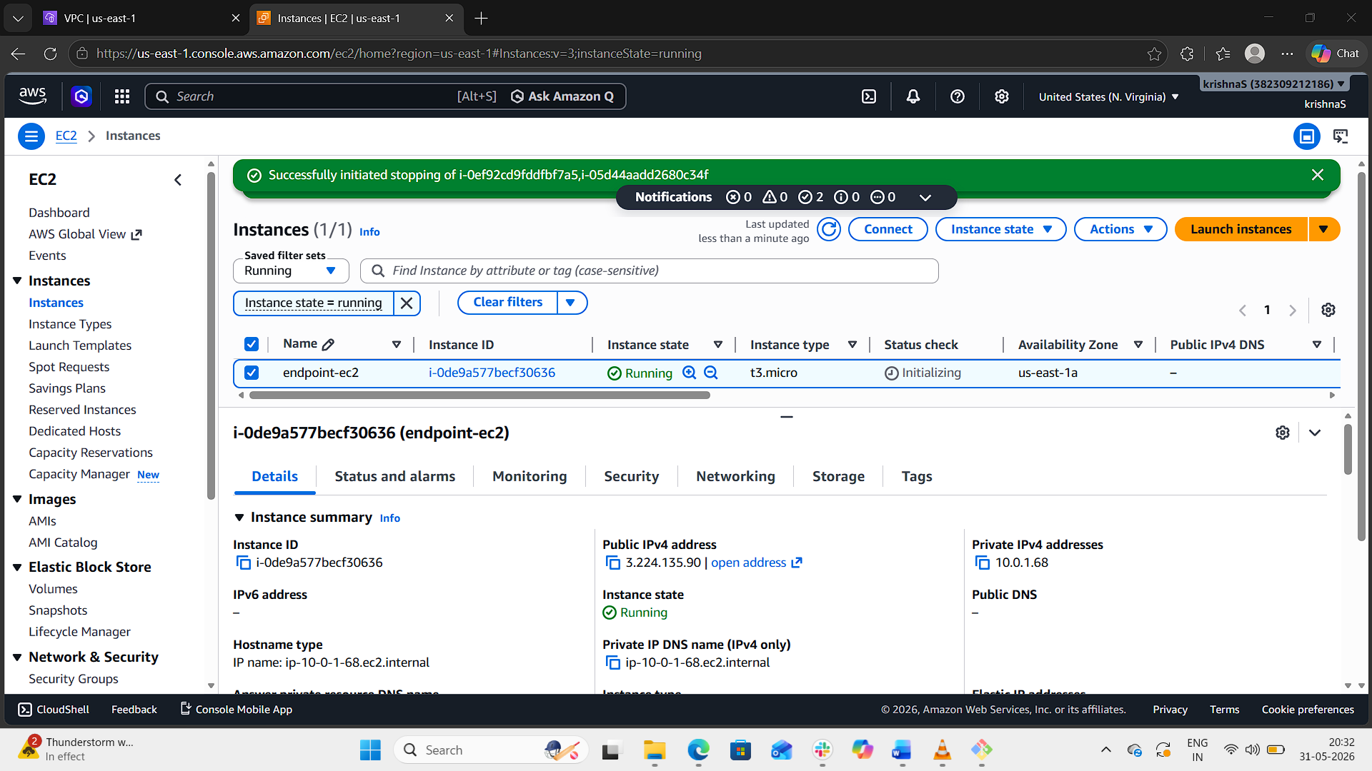
Step 8: Create IAM Role for EC2
- Open AWS Identity and Access Management.
- Go to Roles.
- Click Create role.
- Select:
  - AWS Service
  - EC2
- Click Next.
- Attach policy:
  - AmazonS3ReadOnlyAccess
- Click Next.
- Enter role name:
  - EC2-S3-Role
- Click Create role.
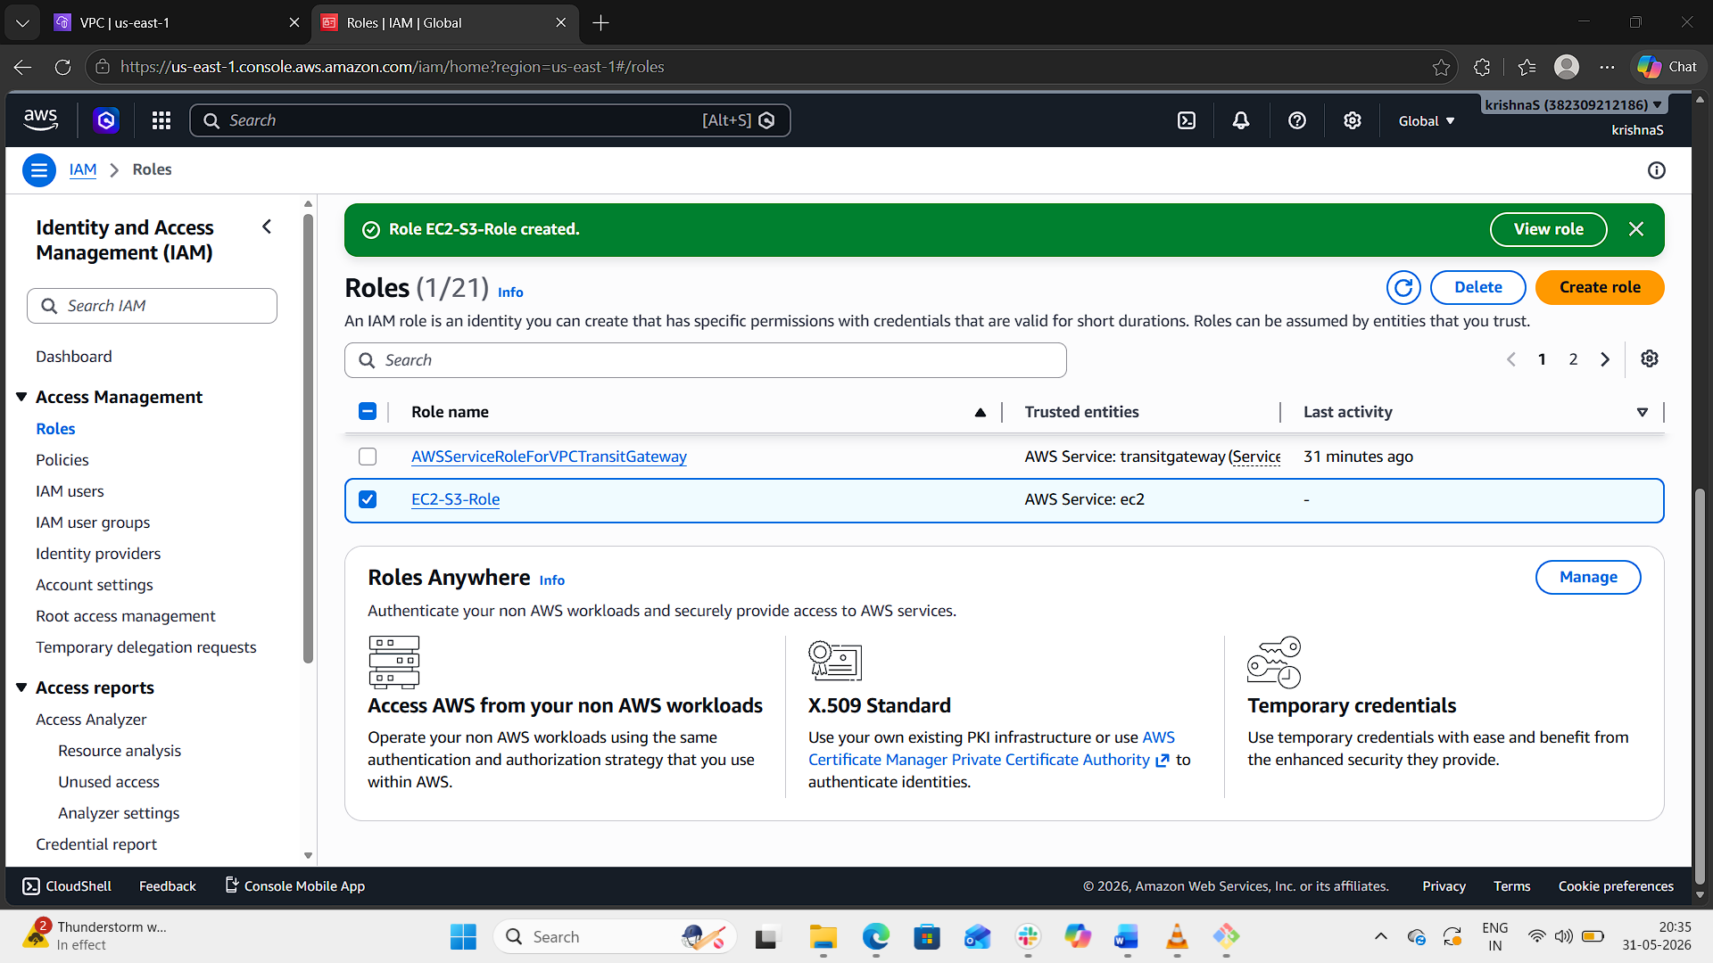
Step 9: Attach IAM Role to EC2 Instance
- Open EC2 Dashboard.
- Select the EC2 instance.
- Click:
  - Actions → Security → Modify IAM Role
- Select:
  - EC2-S3-Role
- Click:
  - Update IAM role
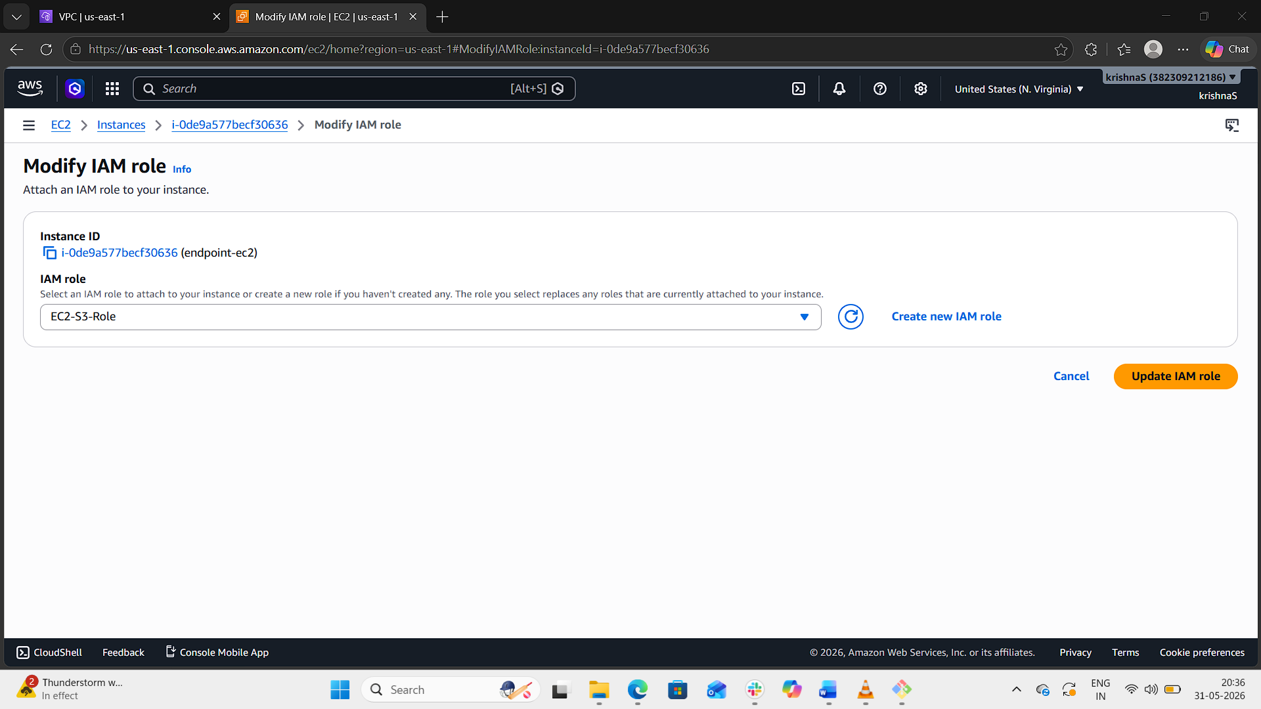
Step 10: Create VPC Endpoint
- Open Endpoints.
- Click Create Endpoint.
Enter:
Setting | Value
Name | s3-endpoint
Service Category | AWS Services
Service | com.amazonaws.us-east-1.s3(gateway)
VPC | endpoint-vpc

Step 11: Select Route Table
Under Route Tables:
- Select:
  - endpoint-rt
Policy:
- Full Access
Click:
- Create Endpoint
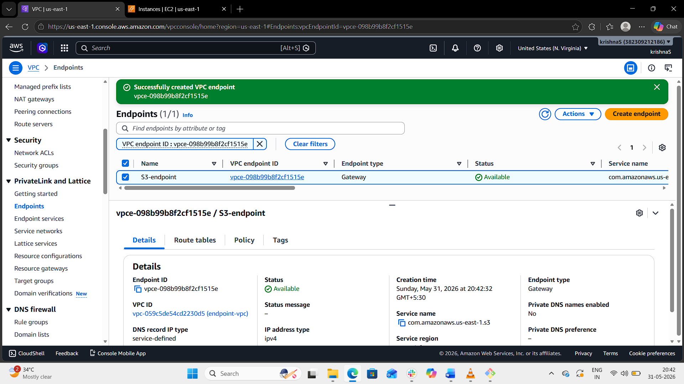
Step 12: Verify Endpoint Creation
- Open Endpoints.
- Verify status:
  - Available
Step 13: Verify VPC Endpoint Connectivity
- Connect to EC2 instance using SSH.
Example:
ssh -i key.pem ec2-user@<public-ip>
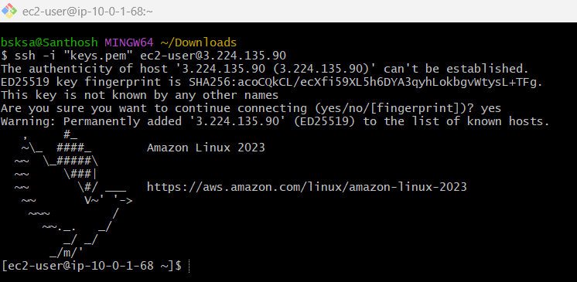
- Verify IAM credentials:
aws sts get-caller-identity
- Verify S3 connectivity:
aws s3 ls
If the command lists S3 buckets successfully, the VPC Endpoint is working correctly.
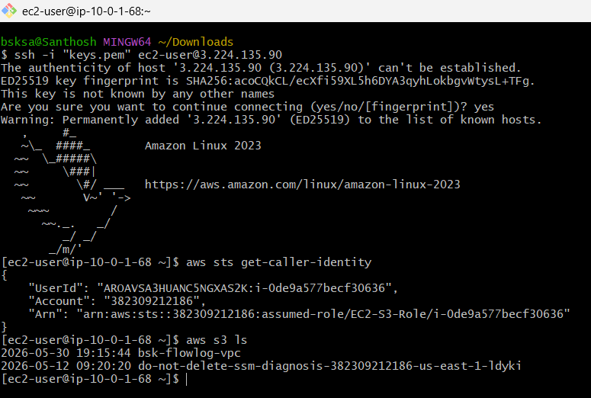
Result
Successfully configured:
- VPC
- Subnet
- Internet Gateway
- Route Table
- EC2 Instance
- IAM Role
- S3 VPC Endpoint
The EC2 instance can now privately access Amazon S3 through the VPC Endpoint.

